Packages
=========
=> When we want to logically group the related modules based on the functionality into one bundle, we can specifically say that bundle as "package".
=> module ==> consisting of functions, classes etc.
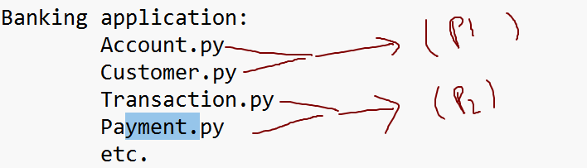
=> Packages are required for:
1) to organize the application code
2) to avoid name conflicts

Ex:
---
Order.py
Order.py
Application: Ecommerce
package1: com.online.customer
Order.py
Package2: com.online.delivery
Order.py

3) to organize the classes in the project etc.

Package ==> Directory + __init__.py

