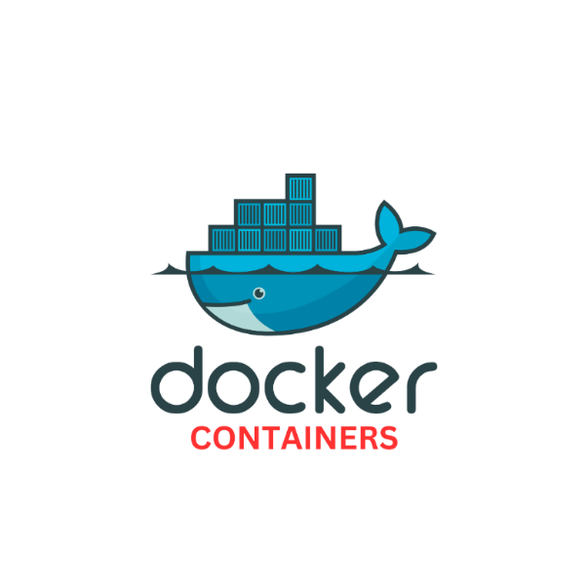

- DOCKER CONTAINERS:

- A container is a runnable instance of an image. You can create, start, stop, move, or delete it.
- Use containers to Build, Share and Run your applications.
- It is a standard unit of software that packages up code and all its dependencies so the application runs quickly and reliably from one computing environment to another.
- A Docker container image is a lightweight, standalone, executable package of software that includes everything needed to run an application: code, runtime, system tools, system libraries and settings.
- Docker Containers Are Everywhere: Linux, Windows, Data center, Cloud, Serverless, etc.
DOCKER CONTAINERS ARE:
- Flexible: Even the most complex applications can be containerized.
- Lightweight: Containers leverage and share the host kernel.
- Interchangeable: Can deploy updates and upgrades on-the-fly.
- Portable : It can build locally, deploy to the cloud, and run anywhere.
- Scalable: It can increase and automatically distribute container replicas.
- Stackable: It can stack services vertically and on-the-fly
- CONTAINER ARCHITECTURE:
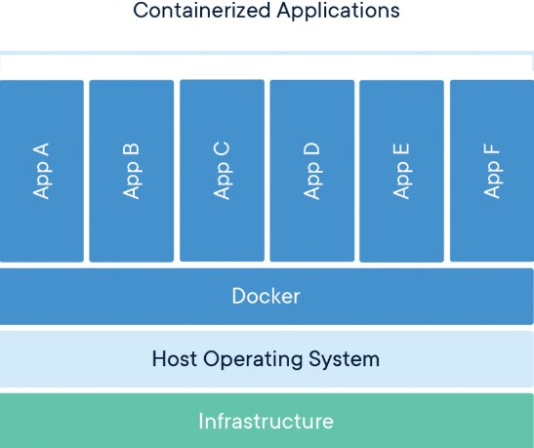
- DOCKER CONTAINERS ARE EVERYWHERE:

- Docker Containers Are Everywhere: Linux, Windows, Data center, Cloud, Serverless, etc.
- The statement "Docker containers are everywhere" means that Docker container technology has become widely adopted across various computing environments, from local development machines to large cloud platforms, making it a prevalent method for deploying and running applications due to its portability, efficiency, and isolation capabilities; essentially, most modern applications are now built and deployed using Docker containers.
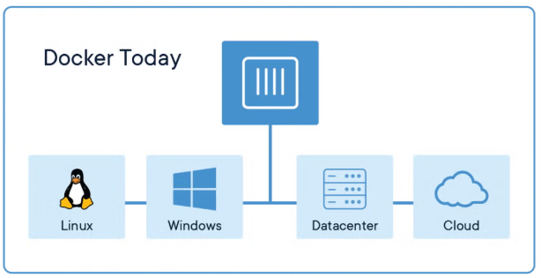

- CONTAINERS VS VIRTUAL MACHINES:
- Containers and virtual machines have similar resource isolation and allocation benefits, but function differently because containers virtualize the operating system instead of hardware.
- Containers are more portable and efficient.
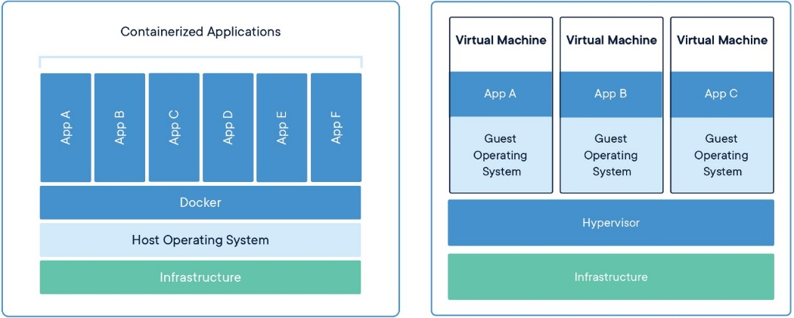
CONTAINERS:
- Containers are an abstraction at the app layer that packages code and dependencies together. Multiple containers can run on the same machine and share the OS kernel with other containers, each running as isolated processes in user space. Containers take up less space than VMs (container images are typically tens of MBs in size), can handle more applications and require fewer VMs and Operating systems.
VIRTUAL MACHINES:
- Virtual machines (VMs) are an abstraction of physical hardware turning one server into many servers. The hypervisor allows multiple VMs to run on a single machine. Each VM includes a full copy of an operating system, the application, necessary binaries and libraries – taking up tens of GBs. VMs can also be slow to boot.

- CONTAINER LIFECYCLE:

- The complete lifecycle of a docker container revolves around five phases:
- Create phase
- Running phase
- Paused phase / unpause phase
- Stopped / Exited phase
- Killed phase
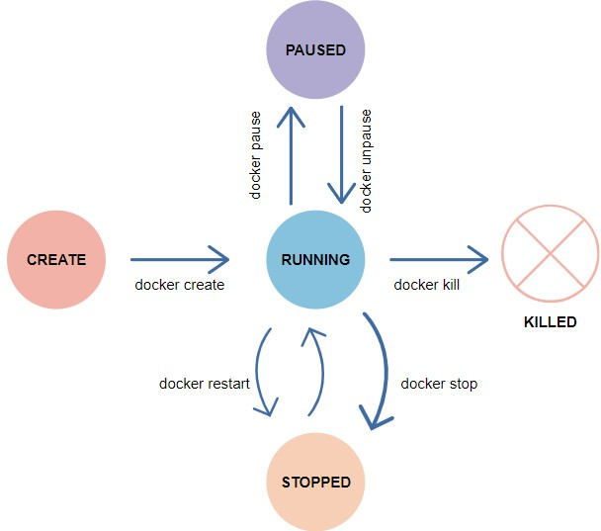
CREATED: This is the initial state of a Docker container after it has been created, but before it has been started.
RUNNING: When a Docker container is started, it transitions to the running state. In this state, the container is actively executing its processes.
PAUSED: If a container is paused, it is temporarily stopped from running its processes, but it is not terminated.
EXITED: If a container's main process completes, the container stops and transitions to the exited state.
DEAD: If a container fails to start, it is in the dead state. Containers in this state cannot be restarted and must be recreated.

- RUNNING CONTAINERS:

- Docker runs processes in isolated containers. A container is a process which runs on a host. The host may be local or remote.
- When you execute docker run, the container process that runs is isolated in that it has its own file system, its own networking, and its own isolated process tree separate from the host.
SYN: $docker run [OPTIONS] IMAGE[:TAG|@DIGEST] [COMMAND] [ARG...]
Options: -i : Gives us an interactive shell into the running container
-t : Will allocate a pseudo-tty
-d : The daemon mode / background process
--name: Give the container name

NOTE: You can specify sh as the [COMMAND], combined with the -i and -t flags, to start an interactive shell in the container.
#docker run -it IMAGE sh
#docker run -it ubuntu bash

FOREGROUND AND BACKGROUND:
- When you start a container, the container runs in the foreground by default. If you want to run the container in the background instead, you can use the --detach (or -d) flag.
- This starts the container without occupying your terminal window.
#docker run -d IMAGE
#docker run -d nginx
#docker ps

MANIPULATING DOCKER IMAGES:
Create a new container using centos image:
#docker run -i -t centos:latest /bin/bash
Now container to open terminal window
Run commands on a container
To exit a container:
#exit
To list running and exited containers:
#docker ps -a
#docker container ls
To list only running containers:
#docker ps
To run a container with name:
#docker run -it -d --name sample ubuntu
#docker ps
#docker ps -a

DOCKER RENAME:
- To rename a container.
#docker rename <current_container_name> <new_container_name>
#docker rename sample test
#docker ps

DOCKER PAUSE / UNPAUSE:
- Pause all processes within one or more containers
Container Pause:
#docker pause containerID
#container pause test
#docker ps
To Container Unpause:
#docker unpause containerid
#docker unpause test
#docker ps

DOCKER STOP / START:
- Stop and Start one or more running containers.
#docker stop containerid
#docker stop test
#docker ps -a
To start container again:
#docker start test
#docker ps
DOCKER KILL:
- It is used to kill one or more running containers.
#docker kill containerid
Send a KILL signal to a container:
#docker kill test
Send a custom signal to a container (--signal):
# docker kill --signal=SIGHUP test
You can specify a custom signal either by name, or number. The SIG prefix is optional, so the following examples are equivalent:
#docker kill --signal=SIGHUP test
#docker kill --signal=HUP test
#docker kill --signal=1 test

DOCKER RM:
- It is used to remove one or more containers
To remove the container:
#docker rm containerid
#pocker ps -a
Force-remove a running container (--force)
#docker rm -f containerid
#docker ps
Remove all stopped containers:
#docker rm prune
#docker ps -a
Using the xargs Linux utility:
# docker ps --filter status=exited -q | xargs docker rm
DOCKER EXEC:

Container stats:
#docker stats <container_name>
#docker stats cid
Monitor Container:
#docker top cid/name
Removing Containers:
#docker container rm cid (or) #docker rm cid
Removing all stopped containers:
#docker container prune
Docker System and stat:
#docker logs cid
#docker logs -f cid
#docker system
#docker system df
#docker system events [Two terminals] #docker stop containerID / Launch new container
#docker system prune [Delete all stopped and unused containers]
#docker system prune -a [Delete all images and stopped containers]

PORT FORWARDING:
#docker run -d -p <host_port>:<container_port> <image>:<tag>
#docker pull nginx
#docker run --name mynginx -d -p 8080:80 nginx/imageid
Go To Web Browser
http://10.10.10.10:8080/
#docker logs cid
#docker logs -f cid

Allocate Memory for Container:
#docker status ContID
#docker run -d -p 8000:80 -m 512m nginx [Container memory limit 512m max]
#docker run -d -p 8000:80 -m 512m --cpu-quota=50000 nginx [cpulimit 50000(50%) total cpu size 100thousend]

