Java8 Features
- default and static methods in interface
- functional interface
- lambda expression
- method reference operator
- Optional class
- Stream API
- Date/Time API
- Base64 Encoder
- CompletableFuture class
default and static methods in interface
what is an interface?
- It is a contract for a group of classes to provide implementation.
- Before Java8, an interface is a collection of public static final variables and public abstract methods.
- From Java8+, an interface can also contain default and static methods.
- In a project, suppose an interface is created and hundreds of implementation classes were developed for that interface.
- Assume that, due to some requirement chanage, additional abstract methods are to be added to the interface.
- If new abstract methods are added to the interface, then all the hundreds of implementation classes have to override the new abstract methods.
- Making changes to hundreds of classes will be a time-consuming task and also error-prone.
- A solution provided from Java8+, is you can define default and static methods in the interface.
- If a default method is created in an interface, then its implementation classes can use it as it is, or a class can override it, if required.(But it is not mandatory).
- If a static method is created in an interface, then its implementation classes can not override this method, and they have to use it as it is.

ex:
public interface IoTDevice {
String getDeviceId(); // abstract method
boolean connect(); // abstract method
boolean disconnect(); // abstract method
default String sendHeartbeat(String id) // default method
{
//code
}
static boolean isValidDeviceId(String id) { // static method
// code
}
}
functional interface
* 3 types of interfaces.
1. Normal interface
2. Marker interface
3. Functional interface
* Normal interface – contains more than one abstract method
* Marker interface – an empty interface
* Functional interface – contains a single abstract method.
Note: A functional interface can contain any number of default methods and static methods.
ex:
interface I1 {
void m1(); //abstract method

default void m2() { //default method
//default logic
}

static void m3() { //static method
//logic
}
}
- The above interface has only one abstract method. So, it is called as a functional interface.
ex:
interface I1 {
void m1(); //abstract method

void m2(); //abstract method

default void m3() { //default method
//default logic
}
}
- The above interface has 2 abstract methods, so it is a normal interface.
@FunctionalInterface:
---------------------
- This annotation is used to specify that an interface is a functional interface.
- If more than one abstract method is declared in the interface, then we will get the compile-time error.
ex1:
@FunctionalInteface
public interface MyInterface {
void m1();
void m2();
default void m3() {
S.o.p(“default method”);
}
}
- This example gets compile-time error, because it has 2 abstract methods.
ex2:
public interface MyInterface {
void m1();
void m2();
default void m3() {
S.o.p(“default method”);
}
}
- This example does not get any error. It is considered as a normal interface.

ex3:
@FunctionalInterface
public interface MyInterface {
void m1();
}
- This example is functional interface.

ex4:
@FunctionalInterface
public interface MyInterface {
public abstract void m1();
public abstract boolean equals(Object o);
public abstract int hashCode();
}

- Eventhough this example has 3 abstract methods in the interface, but still it is a functional interface only.

- The methods equals() and hashCode() are added as abstract methods, but they are matching with the methods of Object class.

- So, if we add any Object class methods as abstract methods in an interface, then they are not considered as abstract methods.

- If a class implements this interface then that class must override m1() method, but overrriding equals() and hashCode() methods is optional.

ex5:
@FunctionalInterface
public interface MyInter1 {
void m1();
}

@FunctionalInterface
public interface MyInter2 extends MyInter1 {
}
- Here, MyInter2 is also a function interface. Because it has inherited a single abstract method from the parent MyInter1.
- A functional interface can extend another functional interface, provided if no new abstract methods are declared in the child interface.
ex6:
@FunctionalInterface
public interface MyInter1 {
void m1();
}

public interface MyInter2 extends MyInter1 {
void m2();
}
- Here, MyInter2 is not a functional interface. It will be considered as a normal interface.

ex7:
@FunctionalInterface
public interface MyInter1 {
void m1();
}

public interface MyInter2 extends MyInter1 {
int hashCode();
String toString();
}
- Here, MyInter2 is a functional interface. It has only one abstract method and the remaining two methods are matching with the methods of Object class.

Lambda expression:

- Suppose, if you have a functional interface and you want to implement it then you have to create a class and in that class you have to override the single abstract method of that interface.
- Suppose, if you have a requirement to implement a functional interface multiple times, then you have to create multiple classes, and in each class you have to override the single abstract method of that interface.
- For example, Comparator<T> is a functional interface and You want to implement it to sort the list of employees in empno’s ascending order, then you have to create a class to override compare() method.
- Suppose, if you want to sort the list of employees in mulitple orders(empno’s/ename’s/sal’s/department’s/etc.. ascending or descending) then you have to create mulitple classes to override compare() method.
- So, the number of classes will increase in a project.
- In Java8, a solution is given as lambda expressions.
- Lambda expressions can be used to define the implementation for only functional interfaces, but not for the normal interfaces.

syntax of lambda expression:
(parameters) -> body;
- The number of arguments and type of the arguments should match with the parameters of the abstract method in the functional interface.

- The body of the lambda expression should return a value that must match with the return type of the abstract method.

- If there are zero or more than one arguments then paranthesis is mandatory. If there is a single argument then paranthesis is optional.

- If the body has mulitple statements then curly braces are mandatory, and for a single statement, the curly braces are optional.

- The datatype of the arguments is also optional. But don’t specify the datatype for one argument and not for another argument.

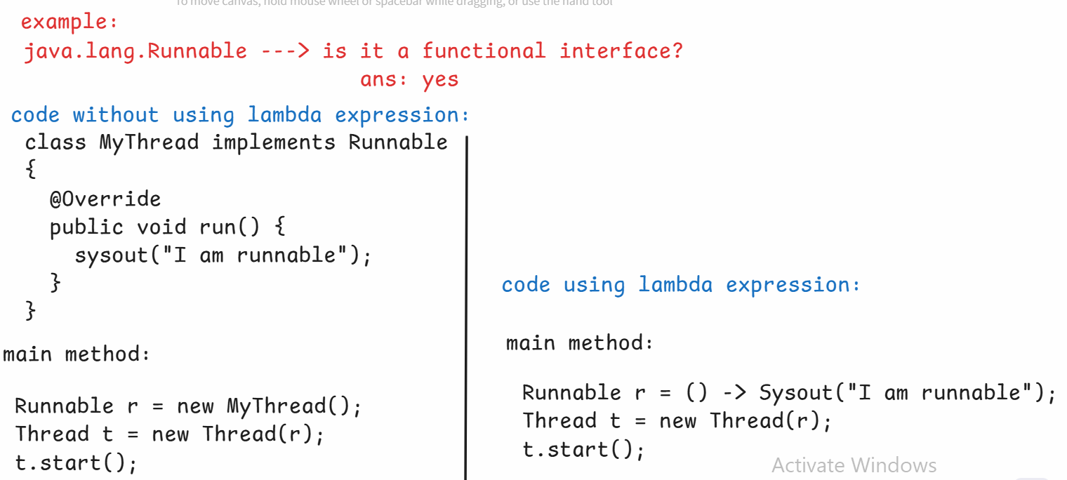

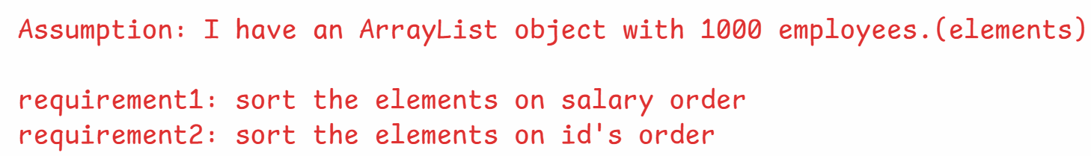
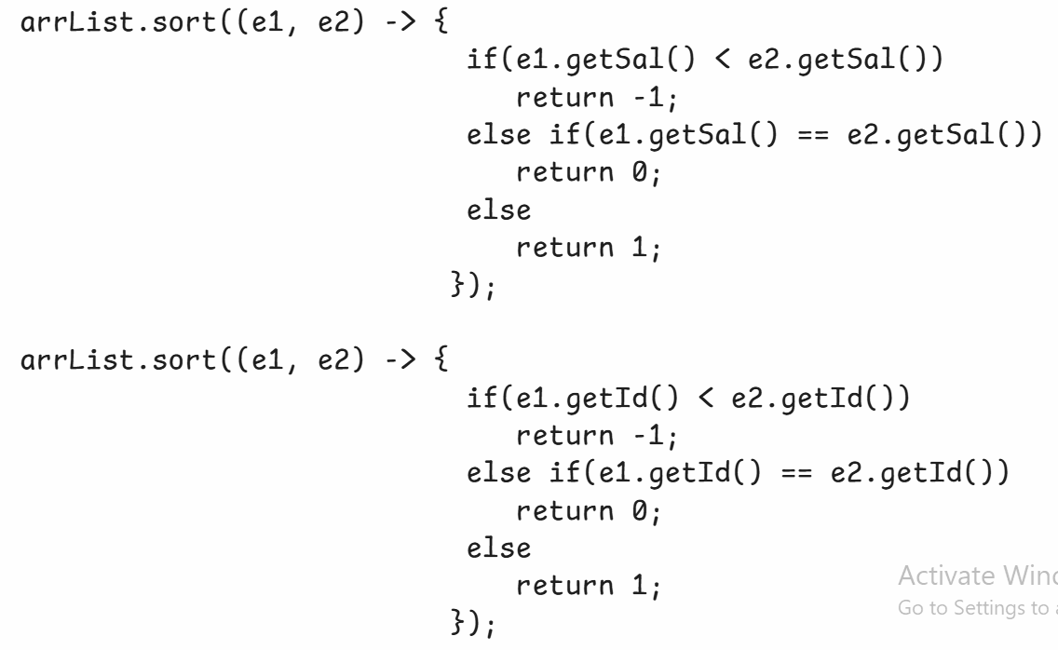

Optional<T> class:
- If an object has null value, and if you are calling method of that object then NullPointerException will be thrown.
- In a project, we have more objects, so the most frequently occrurred exception is NullPointerException.
- To avoid the NullPointerException, you have add the null checks.
ex:
public class Service {
public Employee getEmpById(int empid){
//reads an employee from the database
//if does not exist, then returns null
}
}
public class Controller {
public void show() {
Service s = new Service();
Employee e = s.getEmpById(101);
S.o.p(e.getEname());
S.o.p(e.getSal());
}
}
- In the above example, if 101 employee does not exist then
getEmpById() method returns null.
- In show() method, the variable e stores null and when you call e.getEname(), NullPointerException will be thrown.
- So, we have to modify the Controller class code like below.

public class Controller {
public void show() {
Service s = new Service();
Employee e = s.getEmpById(101);
if(e != null) { // null check
S.o.p(e.getEname());
S.o.p(e.getSal());
}
}
}
- If more null checks are added in the code, then the code becomes complicated.
- To reduce the null checks and also to avoid NullPointerException, Java 8 version has provided Optional<T> class.

- If a method has to return an object, then first it has to store that object into Optional class object and then the method should return the Optional class object.

- Optional class object is a container object, it can store another object inside it.

creating Optional<T> class object:
1. Optional<Employee> opt = Optional.empty();
. creates empty Optional object.

2. Optional<Employee> opt = Optional.of(e1);
. If e1 is not null, then Optional object is created and
inside it e1 object will be stored.
. If e1 is null then NullPointerException will be thrown.

3. Optional<Employee> opt = Optional.ofNullable(e1);
. If e1 is not null, then Optional object is created and
inside it e1 object will be stored.
. If e1 is null then empty Optional object is created.

Methods of Optional<T> class:
--------------------------
1. isPresent() : If value is present in the Optional object then returns true. Otherwise, returns false.

2. get() : Returns the value present in the Optional object.
ex:
Optional<String> opt = Optional.ofNullable(“Hello World”);
if(opt.isPresent()) {
String str = opt.get();
System.out.println(str);
}

3. ifPresent(Consumer<T> consumer) : Executes the given action, if the value is present in the Optional object. Otherwise, do’s nothing.
. This method accepts Consumer object as parameter.
. Consumer is a functional interface, so we can pass lambda expression.
ex:
Optional<String> opt = Optional.ofNullable(“Hello World”);
opt.ifPresent( str -> System.out.println(str) );

4. orElse(T another): if the Optional contains value, it returns that value. If it is empty then returns the another value provided as parameter.
ex1:
Optional<String> opt = Optional.ofNullable(“Hello world”);
String result = opt.orElse(“Bye world”);
System.out.println(result); //output: Hello world
ex2:
Optional<String> opt = Optional.empty();
String result = opt.orElse(“Bye world”);
System.out.println(result); //output: Bye world

5. orElseThrow(): If the Optional contains a value, then returns that value. If it is empty, then throws NoSuchElementException.
ex1:
Optional<String> opt = Optional.ofNullable(“Hello world”);
String result = opt.orElseThrow();
System.out.println(result); //output: Hello world

ex2:
Optional<String> opt = Optional.empty();
String result = opt.orElseThrow(); // throws NoSuchElementException

Stream API
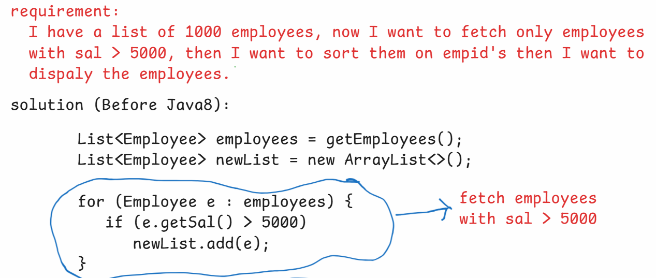
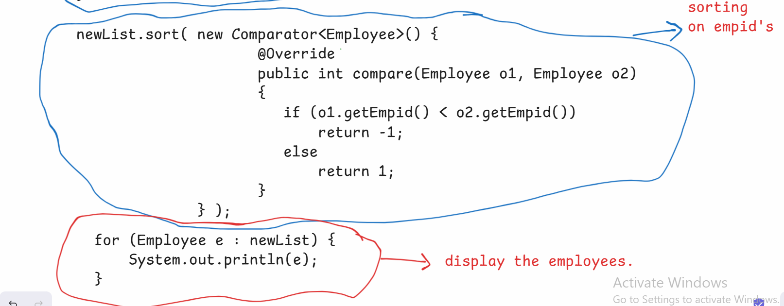
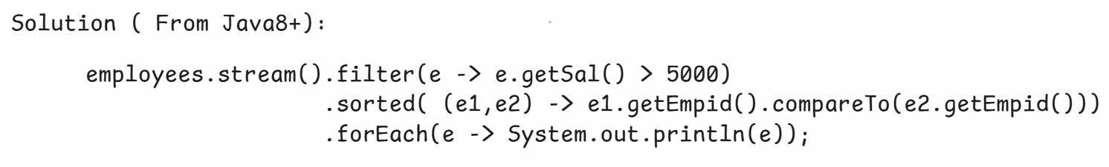
- In Java, a Collection object and a Stream object are used for different purpose.
- A Collection object is used for storing the elements and a Stream object is used for processing the elements.
- A stream represents a flow of data from a source and it allows to perform operations on the data.
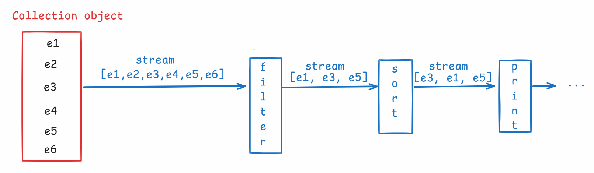

- To systamatically organize a group of elements and to perform operations like, searching or sorting or add or remove etc.., then we use a Collection object.
- To process the elements of a Collection object, we need to iterate the collection with Iterator or we can use for each loop.
- If a Collection object has millions of elements, then processing the elements will take longer time.
- So, to solve this problem, Java8 has provided Stream interface.
- With Stream Api, we can make the code very shorter, to process the elements.
creating a Stream object:
1. we can a Stream for a Collection object.
Stream<Employee> stream = employeesList.stream();

2. we can create a Stream for an array.
Stream<Integer> stream = Arrays.stream(arr);

3. we can create a Stream object for raw values.
Stream<String> stream = Stream.of(“Tom”, “john”, “Jack”);

4. we can create an empty stream object.
Stream<Void> stream = Stream.empty();

- A stream operations are two types.
1.intermediate operations
2.terminal operations.
* intermediate operation means, it transforms a stream to another stream.
* terminal operation means, which produces the end result.
example:

Stream<Employee> stream1 = employeesList.stream();
Stream<Employee> stream2 = stream1.filter( e -> e.getSal() > 1000);

long count = stream2.count();

. Here, filter() is an intermediate operation and count() is a terminal operation.

. filter(), map(), sorted(), skip(), limit(), flatMap(), etc.. are intermediate operations.
. count(), max(), min(), collect(), reduce(), forEach(), etc.. are terminal operations.

filter, map and sorted:
----------------------
- The filter, map, and sorted methods are three fundamental intermediate operations that can be chained together to perform complex data transformations.
- The filter() method is used to select elements from a stream that satisfy a given predicate.
- If the predicate returns true for an element, the element is included in the new stream; otherwise, it's discarded.
- example:
List<Integer> numbers = Arrays.asList(1, 2, 3, 4, 5, 6, 7, 8, 9, 10);
List<Integer> evenNumbers = numbers.stream() .filter(n -> n % 2 == 0) .collect(Collectors.toList());
System.out.println(evenNumbers);
- The map() method is used to transform each element of a stream into another object.
- It applies a function to each element, producing a new stream of the results.
- The type of the elements in the new stream can be different from the original stream.
- example:
List<Integer> numbers = Arrays.asList(1, 2, 3, 4, 5);
List<Integer> squares = numbers.stream().map(n -> n * n) .collect(Collectors.toList());
System.out.println(squares);
- The sorted() method is used to sort the elements of a stream. It returns a new stream with the elements sorted according to a natural order or a custom Comparator.
- example:
List<Integer> numbers = Arrays.asList(5, 2, 8, 1, 9);
List<Integer> sortedNumbersDesc = numbers.stream() .sorted(Comparator.reverseOrder()).collect(Collectors.toList()); System.out.println(sortedNumbersDesc);
- Stream API has the ability to chain these intermediate operations. Each intermediate operation returns a new Stream, allowing multiple operations to be combined into a single, readable pipeline.
- example:
List<Integer> numbers = Arrays.asList(1, 2, 3, 4, 5, 6, 7, 8, 9, 10);
List<Integer> result = numbers.stream().filter(n -> n % 2 == 0)
.map(n -> n * n).sorted().collect(Collectors.toList());
System.out.println(result);

Difference between map and flatMap:
----------------------------------
The map() method transforms each element of a stream by applying a function to it, returning a new stream containing the results. It's used when you want to perform a one-to-one transformation, meaning each input element produces exactly one output element.
Example: Suppose you have a list of strings and you want to get the length of each string.
List<String> words = Arrays.asList("hello", "world", "java");
List<Integer> lengths = words.stream() .map(String::length) .collect(Collectors.toList());
System.out.println(lengths);

The flatMap() method is used when the function applied to each element of the stream returns a stream and you want to flatten these individual streams into a single stream. It performs a one-to-many transformation, where each input element can produce zero, one, or multiple output elements.
Example: Suppose you have a list of lists of integers, and you want to get a single list containing all integers from all inner lists.
List<List<Integer>> listOfLists = Arrays.asList(
Arrays.asList(1, 2),
Arrays.asList(3, 4, 5),
Arrays.asList(6) ); List<Integer> allNumbers = listOfLists.stream() .flatMap(Collection::stream).collect(Collectors.toList()); System.out.println(allNumbers);

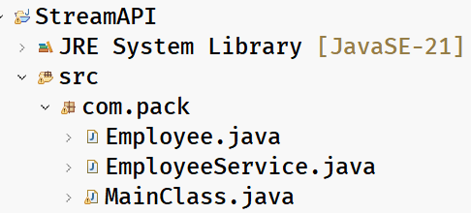
Employee.java
package com.pack;
public class Employee {
private int empno;
private String ename;
private double salary;
private String gender;

public Employee(int empno, String ename, double salary, String gender) {
super();
this.empno = empno;
this.ename = ename;
this.salary = salary;
this.gender = gender;
}

// Getters
// Setters
// toString
}
EmployeeService.java
package com.pack;

import java.util.ArrayList;
import java.util.Arrays;
import java.util.List;
import java.util.stream.Collectors;
import java.util.stream.Stream;

public class EmployeeService {

public static List<Employee> getEmployees() {
ArrayList<Employee> employeesArrList = new ArrayList<Employee>();

employeesArrList.add(new Employee(7921, "Turner", 5000.0, "Male"));
employeesArrList.add(new Employee(7802, "Blake", 4000.0, "Male"));
employeesArrList.add(new Employee(7167, "Mark", 8000.0, "Male"));
employeesArrList.add(new Employee(7177, "Alice", 5000.0, "Female"));
employeesArrList.add(new Employee(7788, "Scott", 6000.0, "Male"));
employeesArrList.add(new Employee(7044, "Sophia", 7000.0, "Female"));
employeesArrList.add(new Employee(7289, "Allen", 3000.0, "Male"));
employeesArrList.add(new Employee(7511, "Mary", 4000.0, "Female"));

return employeesArrList;
}

// fetch "Female" employees
public List<Employee> fetchFemaleEmployees() {

List<Employee> employees = EmployeeService.getEmployees();

/*
Stream<Employee> stream1 = employees.stream();
Stream<Employee> stream2 = stream1.filter( e -> e.getGender().equalsIgnoreCase("Female"));
List<Employee> femaleEmployees = stream2.toList();
return femaleEmployees;
*/

return employees
.stream()
.filter( e -> e.getGender().equalsIgnoreCase("Female") )
.toList();
}

// add 10% hike for "Male" employees.
public List<Employee> employeesAfterHike() {
List<Employee> employees = EmployeeService.getEmployees();

/*
Stream<Employee> stream1 = employees.stream();

Stream<Employee> stream2 = stream1.filter(e -> e.getGender().equalsIgnoreCase("Male"));

Stream<Employee> stream3 = stream2.map( e -> {
e.setSalary(e.getSalary() * 1.1);
return e;
});

List<Employee> maleEmployees = stream3.collect(Collectors.toList());
return maleEmployees;
*/

return employees
.stream()
.filter(e -> e.getGender().equalsIgnoreCase("Male"))
.map(e -> { e.setSalary(e.getSalary() * 1.1); return e; })
.collect(Collectors.toList());

}

// fetch top paid employee
public Employee topPaidEmployee() {
List<Employee> employees = EmployeeService.getEmployees();
return employees
.stream()
.max((e1, e2) -> {
if (e1.getSalary() < e2.getSalary())
return -1;
else if(e1.getSalary() == e2.getSalary())
return 0;
else
return 1;
})
.get();

}

// fetch top3 paid employees
public List<Employee> top3PaidEmployees() {

List<Employee> employees = EmployeeService.getEmployees();

return employees
.stream()
.sorted((e1, e2) -> {
if(e1.getSalary() < e2.getSalary())
return 1;
else if(e1.getSalary() == e2.getSalary())
return 0;
else
return -1;
})
.limit(3)
.toList();

}

// fetch only Names of employees
public List<String> getEmployeesNames() {
List<Employee> employees = getEmployees();
return employees
.stream()
.map(Employee::getEname)
.toList();
}

public void testMethod() {
/*
List<Integer> intsList = new ArrayList<>();
intsList.add(101);
intsList.add(18);
intsList.add(34);
intsList.add(78);
*/

List<Integer> intsList = Arrays.asList(101, 18, 34, 78);
/*
Stream<Integer> stream1 = intsList.stream();
Stream<String> stream2 = stream1.map(String::valueOf);
stream2.forEach(System.out::println);
*/

intsList
.stream()
.map(String::valueOf) // ClassName::staticMethod
.forEach(System.out::println); // objectReference::instanceMethod

}

public void testMethod2() {
List<String> stringsList = Arrays.asList("Jeffery", "Tom", "John", "Miller");
/*
Stream<String> stream1 = stringsList.stream();
Stream<Integer> stream2 = stream1.map(str -> str.length());
stream2.forEach(System.out::println);
*/

stringsList
.stream()
// .map(str -> str.length())
.map(String::length)
.forEach(System.out::println);
}

// Get the average of employees salaries.
public double fetchAverageSalary() {

List<Employee> employees = getEmployees();
/*
Stream<Employee> stream1 = employees.stream();
DoubleStream stream2 = stream1.mapToDouble(e -> e.getSalary());
double avg = stream2.average().getAsDouble();

return avg;
*/

return employees
.stream()
.mapToDouble(Employee::getSalary)
.average()
.getAsDouble();

}

// check whether all employees salary > 5000

public boolean checkSalary() {
List<Employee> employees = getEmployees();

Stream<Employee> stream1 = employees.stream();

boolean flag = stream1.allMatch(e -> e.getSalary() > 5000);

return flag;

}

public void flatMapTest() {
List<Integer> lst1 = Arrays.asList(10, 20, 30);
List<Integer> lst2 = Arrays.asList(40, 50, 60);

List<List<Integer>> lst3 = Arrays.asList(lst1, lst2);

Stream<List<Integer>> stream1 = lst3.stream();
Stream<Integer> stream2 = stream1.flatMap(lst -> lst.stream());

List<Integer> lst4 = stream2.toList();
System.out.println(lst4);
}

}

MainClass.java
package com.pack;

import java.util.List;

public class MainClass {

public static void main(String[] args) {

EmployeeService service = new EmployeeService();
// List<Employee> femaleEmployees = service.fetchFemaleEmployees();

// femaleEmployees.forEach( e -> System.out.println(e) );

// List<Employee> maleEmployees = service.employeesAfterHike();
// maleEmployees.forEach(e -> System.out.println(e));

// Employee topPaidEmployee = service.topPaidEmployee();
// System.out.println(topPaidEmployee);

// List<Employee> top3Employees = service.top3PaidEmployees();
// top3Employees.forEach(System.out::println);

// List<String> names = service.getEmployeesNames();
// names.forEach(System.out::println);

// service.testMethod();
// service.testMethod2();

// double avg = service.fetchAverageSalary();
// System.out.println("average salary of employees : " + avg);

// boolean flag = service.checkSalary();
// System.out.println(flag);

service.flatMapTest();

}
}
Parallel stream:
- parallel stream is a feature of the Stream API.
- It will process the elements of a collection parallelly on multiple CPU cores.
- Parallel stream will split the data into multiple data chunks,
executes each chunk on a separate cpu core and then joins the results of multiple cpu cores and returns the final result.
- parallel stream internally Fork/Join Framework(feature from Java7+).
- A parallel stream can be created by calling parallelStream() on a collection object.
// parallel stream
public static void parallelStreamDemo() {
List<Employee> employees = getEmployees();

long startTime = System.currentTimeMillis();
// sequential processing
employees
.stream()
.forEach(e -> System.out.println(Thread.currentThread().getName()+ " -- " + e));
long endTime = System.currentTimeMillis();

System.out.println("stream time : " + (endTime - startTime) + " ms");

startTime = System.currentTimeMillis();
// parallel processing
employees
.parallelStream()
.forEach(e -> System.out.println(Thread.currentThread().getName()+ " -- " + e));
endTime = System.currentTimeMillis();

System.out.println("parallel stream time : " + (endTime - startTime) + " ms");
}

CompletableFuture<T> class:
- Executor Framework was added in Java5, to simplify the multithreading and to manage and control the thread execution using a high-level API.
- Before Java 5, programmers have to manually create and manage the threads using Thread class and Runnable interface.
- The problems here are like, developers have to create, start and stop the threads, developers have to take care of synchrnonization manually and creating too many threads will consume more system resources.
- So, Java 5 has introduced Executor Framework, where a developer has to define the task and has to submit it to the Executor Framework. The rest of the work like creating the threads, executiong the threads, synchronization, etc.. will be taken care by Executor Framework only.
- The key components of Executor Framework are,
- 1. Executor interface -- Basic interface
- 2. ExecutorService interface – extends Executor interface
- 3. Executors class – utility class, creates ExecutorService instance.
Types of Executors:
1. ExecutorService service = Executors.newSingleThreadExecutor();
* creates a single thread, processes the tasks sequentially.
* Suppose, if 2 tasks are submitted to the ExecutorService, then first one thread is created to execute task1, afte that thread dies, another thread is created to execute task2.
2. ExecutorService service = Executors.newFixedThreadPool(n);
* creates a fixed number of threads.
* It is good for executing controlled number of parallel tasks.
3. ExecutorService service = Executors.newCachedThreadPool();
* creates new threads as needed and also reuses existing threads.
4. ExecutorService service = Executors.newScheduledThreadPool(n);
* It is used when you want to execute scheduled tasks, repeatedly at fixed intervals.

How to submit my task to the ExecutorService?
1. void execute(Runnable runnable)
2. Future submit(Callable callable)
Runnable and Callable are the functional interfaces.
Runnable’s abstract method -- void run();
Callable’s abstract method -- V call() throws Exception.
- Runnable doesn’t return the result and doesn’t throw Exception. But Callable returns the computed result, if unable to compute then throws Exception.
- Future<T> is an interface from Java 5+ and it is to hold the result of a task, going to be generated in future.
ex:
public class TestClass {

public static void main(String[] args) throws Exception {

ExecutorService executor = Executors.newFixedThreadPool(2);

Callable<String> task = () -> {

Thread.sleep(5000);
return "hello".toUpperCase();
};

Future<String> future = executor.submit(task);

System.out.println("I am continuing my work .....");
System.out.println("My work is completed ...... ");

System.out.println("The computed result : " + future.get());

executor.shutdown();

}

}

example with CompletableFuture<T> class:
public class MainClass {

public static void main(String[] args) throws Exception {

Supplier<String> supplier = () -> {
sleep(5000);
return "Hello world!";
};

CompletableFuture<String> future = CompletableFuture.supplyAsync(supplier);

System.out.println("I am continuing my work .....");

future.thenAccept(System.out::println);

System.out.println("Still my work is going on ......");
System.out.println("I am done with my work ......");

Thread.currentThread().join();

}
private static void sleep(long ms) {
try {
Thread.sleep(ms);
}
catch(InterruptedException ex) {
System.out.println(ex);
}
}

}

example with thenCombine():
public class DemoClass {

public static void main(String[] args) {

CompletableFuture<String> cf1 = CompletableFuture.supplyAsync(() -> "AshokIT");
CompletableFuture<String> cf2 = CompletableFuture.supplyAsync(() -> " Technologies");

CompletableFuture<String> cf3 = cf1.thenCombine(cf2, (r1, r2) -> r1 + r2);

cf3.thenAccept(System.out::println);

}

}

Date/Time API

- Before Java8 version, we have java.util.Date and java.util.Calendar classes to work with data and time values.
- The problem with these classes is, they are mutable objects. So, in mulithreaded applications, if one thread changes the value, then it effects on other thread. This is a bug.
- The other issue is, the year starts from 1900, not from 0.
- For example, if I create,
- Date d = new Date(120, 0, 21);
- then, it represents the year 2020, not 120.
- So, Java 8 has provided, new classes to work with Date and Time values in java.time package.

- LocalDate class
- LocalTime class
- LocalDateTime class
- Period class

For example,
LocalDate today = LocalDate.now(); //The LocalDate object is
created with current system date.
LocalDate expDate = LocalDate.of(2025, 11, 30);

- LocalDate, LocalTime, and LocalDateTime classes objects are immutable objects. So, if you make any changes then new objects are created with results.
ex:
LocalDate date1 = LocalDate.of(2025, 1, 31);
LocalDate date2 = date1.plusDays(3);
S.o.p(date1); //output: 2025-01-31
S.o.p(date2); //output: 2025-02-3
Note: you have other methods like,
plusMonths(), plusYears(), plusWeeks(), minusDays(), minusMonths(), minusYears(), minusWeeks().

LocalTime currentTime = LocalTime.now(); //system time
LocalTime endTime = LocalTime.of(18, 30, 45);
- Suppose, if you want to find the difference between two dates in terms of days then,

- LocalDate d1 = LocalDate.of(2024, 8, 15);
- LocalDate d2 = LocalDate.of(2025, 2, 18);
- long days = ChronoUnit.DAYS.between(d1, d2);
- System.out.println("difference in days : " + days);

- suppose, if you want to find the difference between two times, interm of minutes then,
LocalTime t1 = LocalTime.of(9, 35, 40);
LocalTime t2 = LocalTime.of(19, 15, 39);
long minutes = ChronoUnit.MINUTES.between(t1, t2);
System.out.println("difference in minutes : " + minutes);

- Period class compares the given two dates based on the values of dates, months and years. It means, it will not provide the as the difference in total no of days or total months or total years.

LocalDate d1 = LocalDate.of(2024,02, 20);
LocalDate d2 = LocalDate.now();
Period p = Period.between(d1, d2);
S.o.println(p.getDays()); //output: 0
S.o.println(p.getMonths()); //output: 0
S.o.println(p.getYears()); //output: 1

Base64 Encoding and Decoding:
--------------------------
- Base64 class is provided in Java8, under java.util package for encoding and decoding the data in Base64 format.
- Base64 is an encoding scheme that converts binary data(bytes) into encoded string(ASCII string).
- Base64 class has provided two static inner classes called Encoder and Decoder, where Encoder class converts binary data to encoded string and Decoder class will do the reverse.
- Encoding and Decoding are concepts are used for data storage, security and transmission.

package com.pack;
import java.util.Base64;
import java.util.Base64.Decoder;
import java.util.Base64.Encoder;
public class Base64Example {

public static void main(String[] args) {

Encoder encoder = Base64.getEncoder();

String str = "hello@world";

String encoded = encoder.encodeToString(str.getBytes());
System.out.println("original : " + str);
System.out.println("encoded string : " + encoded);

System.out.println("=================");
Decoder decoder = Base64.getDecoder();
byte[] byts = decoder.decode(encoded);
String original = new String(byts);
System.out.println("encoded string : " + encoded);
System.out.println("original : " + original);
}
}

