Multithreading
Introduction:
- When you run any application on your computer, the operating system will create a process and loads that process into RAM.
- When you run multiplications on your computer, the operating system will creates will create multiple processes and loads them into RAM.

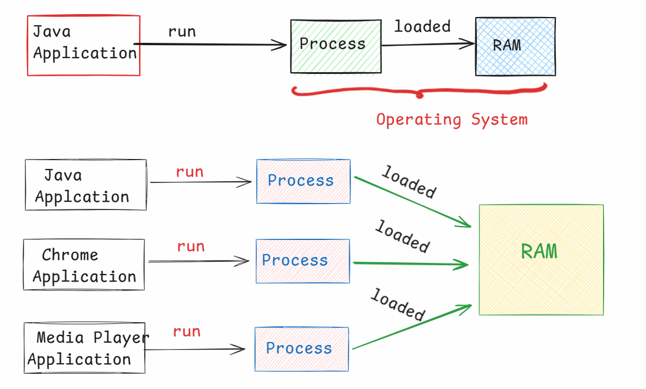
- If the system has a single CPU Core, then all the processes will run on the Same core. So, the performance of the computer is slow.
- If the system has multiple CPU cores, like 4 cores/8 cores, then at a time, the OS can run 4 processes/8 processes concurrently(Exactly at the same time).
- Within a process/application, if you want to execute multiple tasks independently at the same time then you have to use a mechanism called “Multithreading”.

what is a Thread?
--------------
- A Thread is a group of instructions to perform a task, which are executing independently/separately from the rest of the application.
- For example:
- Suppose, you have an application, which has the tasks like upload the students details to the database and also generate the reports for the students.
- if these two tasks are executing sequentially, then tasks are delayed and application will take more time to complete.
- If you execute the two tasks parallely by creating two threads, then the tasks are finished fastly and application provides a good performance.

Q) what is the difference between process and thread?
A) 1. A process contains threads, but thread doesn’t contain process.
2. Switching from process to process will take more time for
CPU, but switching from thread to thread will take less
time for CPU. This switching is called context switch.
3.Each process will have a separate address space. But threads doesn’t have separate address space.

creating threads:

- In Java, threads can be created in 2 ways.
- extend Thread class
- implement Runnable interface.
- In both the ways, you have to override the run() method in the class to define the logic of a thread.
ex1:
class MyThread1 extends Thread {
@Override
public void run() {
//logic
}
}
ex2:
class MyThread2 implements Runnable {
@Override
public void run() {
//logic
}
}
Note: Runnable is a functional interface, because it has a single abstract method called run().

- After creating the thread classes, next we need to start the threads.
- If a thread is created by extending Thread class, then we can directly start the thread by calling start() method.
- If a thread is created by implementing Runnable interface, then we can’t directly start the thread.
So, we need to wrap up the Runnable object into a new thread
object, then we need to start().
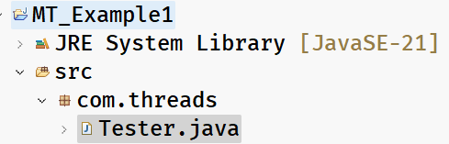
Tester.java
/**
* This demo example of multi-threading has 2 threads.
* one thread prints 1-10 numbers, and
* other thread prints 11-20 numbers on the console.
* Using multi-threading, we are executing the two threads
* in parallel.
*/
package com.threads;

class MyThread1 extends Thread {
@Override
public void run() {
for (int i = 1; i <= 10; i++) {
System.out.println("i = " + i);
try {
Thread.sleep(4000); // 4000ms(4s)
} catch(InterruptedException ex) {
System.out.println(ex);
}
}
}
}
class MyThread2 implements Runnable {
@Override
public void run() {
for (int j = 11; j <= 20; j++) {
System.out.println("j = " + j);
try {
Thread.sleep(4000); // 4000ms(4s)
} catch(InterruptedException ex) {
System.out.println(ex);
}
}
}
}
public class Tester {

public static void main(String[] args) {

MyThread1 t1 = new MyThread1();

Thread t2 = new Thread(new MyThread2());

t1.start();
t2.start();

}

}
Thread life cycle:
----------------
- Thread life cycle means, from thread creation to thread destruction, it will undergo different phases and these phases forms the life cycle.
- Newborn
- Runnable
- Running
- Non-Runnable
- Dead

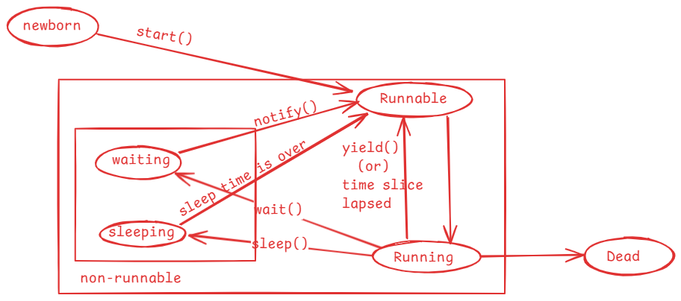

- when a thread object is created then the thread enters into newborn state.
- when start() method is called on a thread object then the thread is moved to the Runnable state.
- mulitple threads can sit in Runnable state at a time.
- Thread schedular will pick up one thread from Runnable state and moved
it into Running state.
- In Running state, run() method is called.
- When the time slice is lapsed/when yield() method is called, a thread is moved back from Running to Runnable state by the schedular.
- when sleep() is called, a thread is moved from Running state to the non-runnable state.
- once sleep time is completed, a thread is moved to Runnable state.
- when wait() is called, a thread is moved from Running state to non-runnable state.
- when notify()/notifyAll() method is called, then a waiting thread goes to Runnable state.
- If a thread’s execution is finished, then it goes to dead state.

key methods of Thread class:
------------------------------
- getId() : returns the identifier of a thread.
- getName(): returns the name of a thread.
- setName(String name): changes the name of this thread to the given name.
- getPriority(): returns the proirity of a thread.
- setPriority(int priority): changes the priority of this thread to the given value.
- start(): moves this thread from newborn state to runnable state.
- isAlive(): returns true, if a thread is alive.
- isDaemon() : return true, if a thread daemon
- setDaemon(boolean): changes this thread to a daemon thread.
- getState(): returns the state of this thread.
- yield(): It provides a hint to the schedular that the current thread is willing to come out of Running state, and want to give a chance for other high priority threads to enter into Running state. The schedular may accept it or may ignore it.
- join(): This method will join this thread execution with another. So, the other thread will be suspended, until this joined thread is completed.
- sleep(milliseconds): It makes a thread to enter into a sleeping state for a given milliseconds.

Thread priority variables:
-----------------------
- In java.lang.Thread class, three public static final variables are provided to represent the thread priority.
public static final int MIN_PRIORITY = 1;
public static final int MAX_PRIORITY = 10;
public static final int NORM_PRIORITY = 5;
- A thred priority can be in between 1 to 10.
- The default priority is 5.
- If you change the priority of a thread to < 1 or > 10, then
IllegalArgumentException will be thrown.
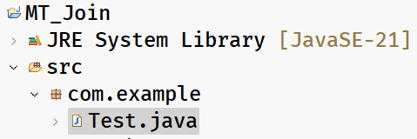
Test.java
/**
* Example on join() method:
* This program has two threads, main thread and my thread.
* main thread prints 101 to 129, and my thread prints 1 to 50.
* We want to join my thread with main thread after printing 115.
* Now, main thread execution will be suspended, my thread continues.
* After my thread is dead, main thread will resume, and continues.
*
*/
package com.example;

class MyThread extends Thread {
@Override
public void run() {

for (int i = 1; i <= 50; i++) {
System.out.println("i = " + i);
try {
Thread.sleep(3000);
} catch(InterruptedException ex) {
System.out.println(ex);
}
}

}
}
public class Test {

public static void main(String[] args) throws InterruptedException {

MyThread t1 = new MyThread();
t1.start();

for (int j = 101; j <= 129; j++) {
System.out.println("j = " + j);
Thread.sleep(3000);
if (j == 115)
t1.join();
}

}

}

Q) How can you get a Thread object for a current thread?
Ans: Thread.currentThread();
Q) what is the default name and priority of the main thread?
Ans: name is “main” and priority is 5.

Types of threads:
- In Java, we have 2 types of threads.
- 1. user thread
- 2. daemon thread

User thread:
* A user thread is a thread that keeps the JVM to wait until it finishes execution.
* By default, every thread is a user thread only including main thread.
* JVM waits for all the user threads to finish, then it will shutdown the application.

Daemon thread:
* Daemon thread is a thread that is used for executing background support tasks.
* JVM does not wait, until daemon thread finishes the execution.
* Daemon threads are suitable for any background activities like performance monitoring, garbage collection, etc..
* Daemon threads will die automatically when all user threads are finished.
* To make a thread as a daemon thread, call setDaemon(true), before starting the thread.

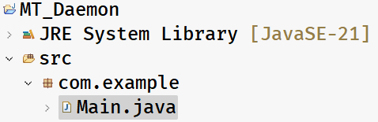
Main.java
package com.example;

class MyThread1 extends Thread {
@Override
public void run() {
for (int i = 1; i <= 10; i++) {
System.out.println("i = " + i);
try {
Thread.sleep(5000);
} catch(Exception ex) {
ex.printStackTrace();
}
}
System.out.println("MyThread1 is finished");
}
}
class MyThread2 extends Thread {
@Override
public void run() {
for (int j = 111; j <= 145; j++) {
System.out.println("j = " + j);
try {
Thread.sleep(5000);
} catch(Exception ex) {
ex.printStackTrace();
}
}
System.out.println("MyThread2 is finished");
}
}
public class Main {

public static void main(String[] args) {

MyThread1 t1 = new MyThread1();
MyThread2 t2 = new MyThread2();

t1.start();

t2.setDaemon(true);
t2.start();
}
}

Threads synchronization
- If multiple threads are using a shared resource and trying to read/modify the data at the same time then we will get unpredictable results. It is also called race condition.
- Suppose, two people are withdrawing the money from the same bank account at the same time, then there is a chance of overdrawing the money.
- For example, balance available is 5000.0, and the two people at a time can see the balance as 5000.0 and if they withdraw 3000.0 each, then the total amount withdrawn is 6000.0. This is overdrawing the amount and leads to data inconsistency.
- Threads synchronization controls access to a shared resource by multiple threads, by allowing only one thread to act on the shared resource at the same time.
- Threads synchronization can be implemented using synchronized keyword.
- With synchronized keyword(access modifier) we can create synchronized methods or synchronized blocks.
- synchronization works by acquiring the lock on an object by a thread.
- In Java, every object has a lock/monitor.
- A thread acquires the lock on the object, by calling synchronized method or synchronized block.
- Only one thread can acquire the lock on an object at a time.
- If two threads are calling a synchronized method at the same time, then one of the two threads acquires lock on the object. The other thread will be kept waiting.
- when the execution of a synchronized method/block is completed by a thread then the lock gets released.
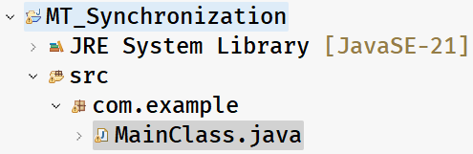
MainClass.java
/*
* In this example, Course object is a shared resource for two threads.
* The two threads are trying to register for the same course
* which has only one last seat available.
* If synchronization is not applied, there is possibility that
* the two threads might have been registered for the same last seat.
* To avoid this inconsistency, we made the registerForCourse() method
* as synchronized.
* One thread at a time can execute the synchronized method, so that
* we can avoid the inconsistency.
*/
package com.example;
class Course {
private String courseName;
private int numOfSeatsAvailable;

public Course(String courseName, int numOfSeatsAvailable) {
super();
this.courseName = courseName;
this.numOfSeatsAvailable = numOfSeatsAvailable;
}

public synchronized void registerForCourse(int rollno) {

try {
if ( this.numOfSeatsAvailable - 1 < 0 ) {
throw new Exception("Sorry, seats are not available!. Your rollno : " + rollno);
}

numOfSeatsAvailable -= 1;

System.out.println("Booking successful!!! Your rollno is : " + rollno);

System.out.println("Available seats now : " + this.numOfSeatsAvailable);
}
catch(Exception ex) {
System.out.println("ERROR : " + ex.getMessage());
}

}

}

class RegisterThread extends Thread {
Course course;
int rollno;
RegisterThread(Course course, int rollno) {
this.course = course;
this.rollno = rollno;
}

@Override
public void run() {
course.registerForCourse(rollno);
}
}

public class MainClass {

public static void main(String[] args) {

Course course = new Course("CSE", 1);

RegisterThread t1 = new RegisterThread(course, 101);

RegisterThread t2 = new RegisterThread(course, 102);

t1.start();

t2.start();

}

}
synchronized block:
-----------------
- Suppose, you have a synchronized method but only some statements of the method if they are executed simultaneously by two threads will cause inconsistency.
- In this case, when one thread is executing synchronized method, the other thread has to wait until the entire method is executed by the thread one. It means, the other thread has to wait for more time unnecessarily.
- So, to reduce the unnecessary waiting time for the threads, we can use synchronized blocks inside a method.
- If one thread is executing synchronized block, the other thread has to wait only until the thread1 has executed the block. So, waiting time is decreased.

- To the synchronized block, we should pass an object, whose lock a thread has to acquire as a parameter.
- If it is a non-static method, we can pass “this” as a parameter.
- If it is a static method, we can pass Classname.class as a parameter.

Q) How many synchronized blocks can be created in a method?
A) zero or multiple
Q) Which can improve the performance of an application, synchronized method or synchronized block?
A) synchronized block.
Deadlock:
- Suppose, we have two threads and two resources.
- thread1 holds the lock on resource1 and waiting for lock on resource2 and thread2 holds the lock on resource2 and waiting for lock on resource1.
- In this case, thread1 is blocked for resource2 and thread2 is blocked for resource1.
- So, the two threads will never complete. This is called deadlock situation.
- Deadlocks can be prevented by making the two threads to acquire the locks on the resources in the same order.
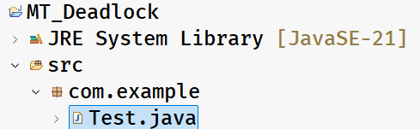
Test.java
package com.example;

class MyThread1 extends Thread {
Object obj1;
Object obj2;

public MyThread1(Object obj1, Object obj2) {
this.obj1 = obj1;
this.obj2 = obj2;
}

@Override
public void run() {
synchronized (obj1) {
System.out.println(Thread.currentThread().getName() + " has acquired lock on resource1");
try {
Thread.sleep(2000);
} catch (InterruptedException ie) {
System.out.println(ie);
}

System.out.println(Thread.currentThread().getName() + " is waiting to acquire lock on resource2");
synchronized (obj2) {
System.out.println(Thread.currentThread().getName() + " has acquired lock on resource2");
}
}
System.out.println(Thread.currentThread().getName() + " : is completed");
}

}

class MyThread2 extends Thread {
Object obj1;
Object obj2;

public MyThread2(Object obj1, Object obj2) {
this.obj1 = obj1;
this.obj2 = obj2;
}

@Override
public void run() {
synchronized (obj2) {
System.out.println(Thread.currentThread().getName() + " has acquired lock on resource2");
try {
Thread.sleep(2000);
} catch (InterruptedException ie) {
System.out.println(ie);
}

System.out.println(Thread.currentThread().getName() + " is waiting to acquire lock on resource1");
synchronized (obj1) {
System.out.println(Thread.currentThread().getName() + " has acquired lock on resource1");
}
}
System.out.println(Thread.currentThread().getName() + " : is completed");
}
}

public class Test {

public static void main(String[] args) {
Object obj1 = new Object();
Object obj2 = new Object();

MyThread1 t1 = new MyThread1(obj1, obj2);
t1.setName("Thread1");

MyThread2 t2 = new MyThread2(obj1, obj2);
t2.setName("Thread2");

t1.start();
t2.start();
}

}

Home work:
Q) what is volatile keyword in multithreading?
Q) What is inter-thread communication in multithreading?

