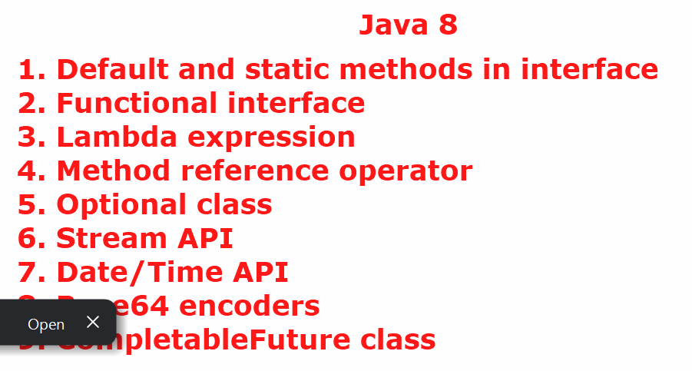
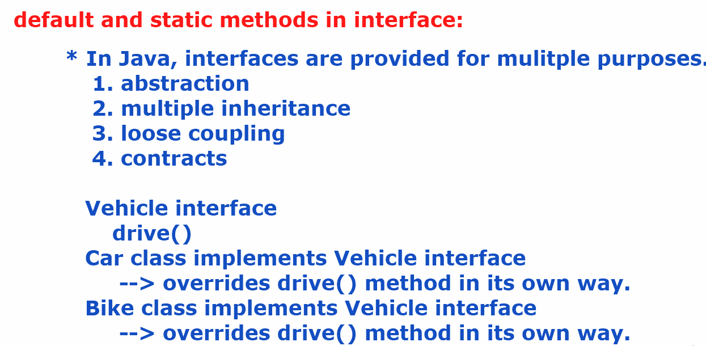

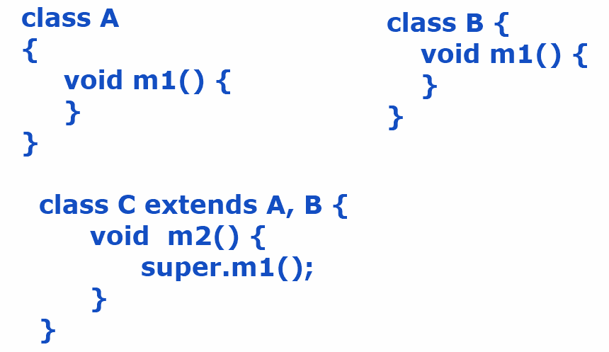
- Here, there is an ambiguity that whose m1() should be called. This is called diamond problem.
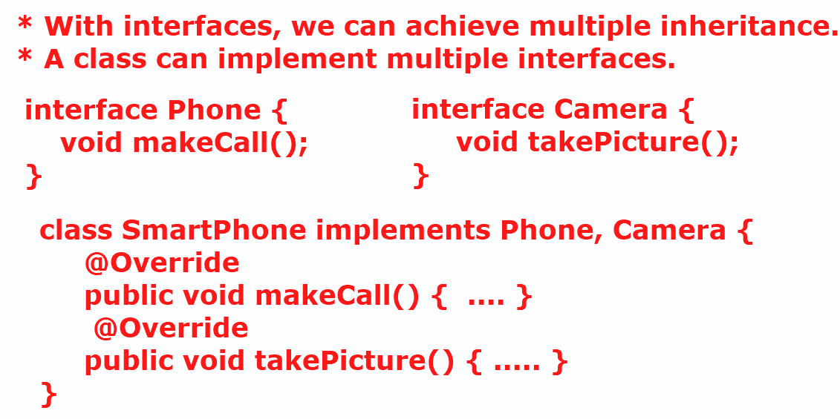
- suppose, if the two interfaces have the same abstract method then the class has to override the abstract method for only once. So, there is no diamond problem in interfaces.
*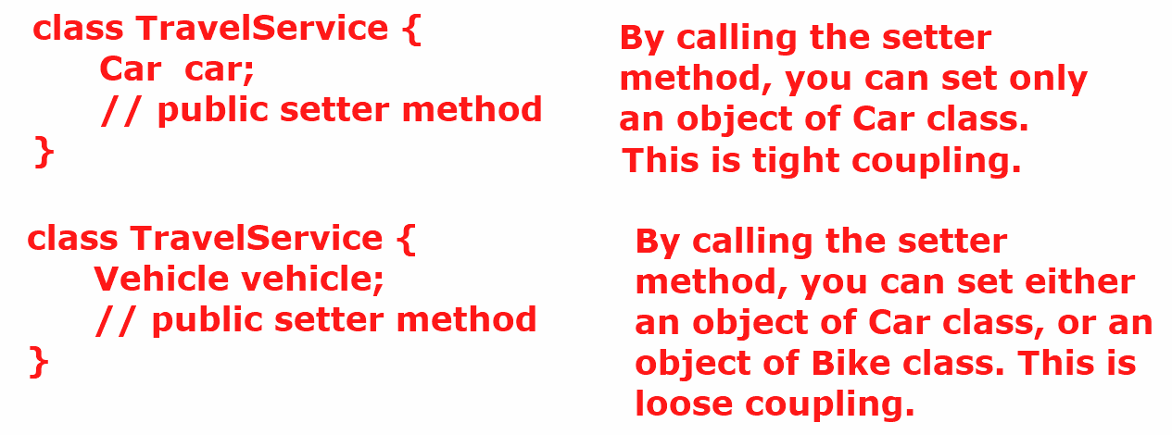

- An interface acts as a contract for the classes who implements that interface. It means, an interface tells the behaviours that a class has to implement.
How many types of interfaces in Java?
Ans: 1. Normal interface ( > 1 abstract method)
2. Marker interface ( empty)
3. Functional interface. ( single abstract method)
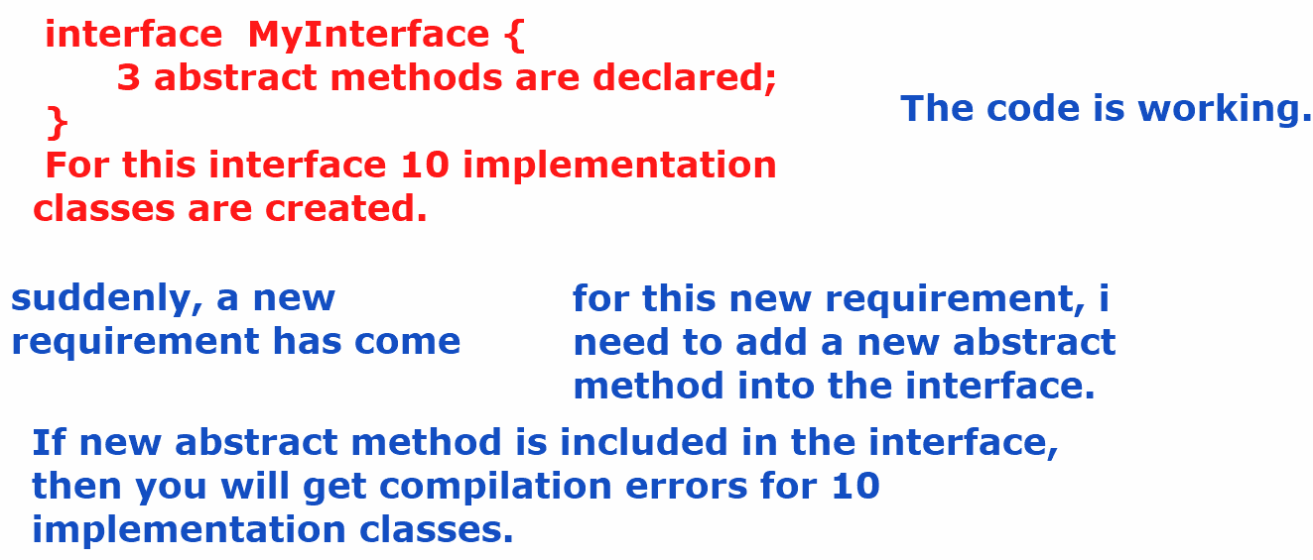
- The solution is reach out all the 10 implementation classes and override the new abstract method there.
- what if there are 100’s of implementation classes for an interface?
- Reaching out to each and every implementation class to override a new abstract method will be a time consuming task and also error-prone.
- what is the solution provided in Java 8?
- Ans: default and static methods in interface.
- Before Java 8, an interface can have public static final variables and public abstract methods.
- From Java 8+, an interface can have public static final variables, public abstract methods, default methods, static methods and private methods also.
- public interface MyInterface {
public static final int MAX_USERS = 100;
public abstract void m1();
public abstract void m2();
public default String sayHello() {
return "Hello";
}
public static void m4() {
System.out.println("static method");
}
private void m5() {
System.out.println("private method");
}
}

- In an interface, if you have added a default method then its implementation classes can use that method as it is or they can override that method, if required.
IoTDevice.java
public interface IoTDevice {
void connect();
void disconnect();
default String sendHeartBeat(String id) {
return "Device : "+ id + " is Active";
}
}
SmartLight.java
public class SmartLight implements IoTDevice {
@Override
public void connect() {
System.out.println("SmartLight connected");
}
@Override
public void disconnect() {
System.out.println("SmartLight disconnected");
}
}
DoorSensor.java
public class DoorSensor implements IoTDevice {
@Override
public void connect() {
System.out.println("Door sensor connected");
}
@Override
public void disconnect() {
System.out.println("Door sensor disconnected");
}
}
Main.java
public class Main {
public static void main(String[] args) {
IoTDevice smartLight = new SmartLight();
smartLight.connect();
smartLight.disconnect();
System.out.println(smartLight.sendHeartBeat("sm001"));
IoTDevice doorSensor = new DoorSensor();
doorSensor.connect();
doorSensor.disconnect();
System.out.println(doorSensor.sendHeartBeat("ds001"));
}
}
output:
SmartLight connected
SmartLight disconnected
Device : sm001 is Active
Door sensor connected
Door sensor disconnected
Device : ds001 is Active
- In an interface, if you have added a static method, then the implementation classes of that interface can not override that method. Because the static method belongs to interface itself.
IoTDevice.java
public interface IoTDevice {
void connect();
void disconnect();
default String sendHeartBeat(String id) {
return "Device : "+ id + " is Active";
}
static void isValidDevice(String id) {
if (id.startsWith("sm") || id.startsWith("ds"))
System.out.println(id + " : valid device");
else
System.out.println(id + " : invalid device");
}
}

- Suppose, if there two interfaces added with same default method and a class implements both the interfaces then how to resolve ambiguity.
- Answer: override the default method in the class then make a call to the default methods of the interfaces
with syntax, InterfaceName.super.methodName();
example:
MyInter1.java
public interface MyInter1 {
default void m1() {
System.out.println("MyInter1 m1() called");
}
}
MyInter2.java
public interface MyInter2 {
default void m1() {
System.out.println("MyInter2 m1() called");
}
}
MyClass.java
public class MyClass implements MyInter1, MyInter2 {
public void m3() {
System.out.println("MyInter3 m3() called");
m1();
}
@Override
public void m1() {
MyInter1.super.m1();
MyInter2.super.m1();
}
}
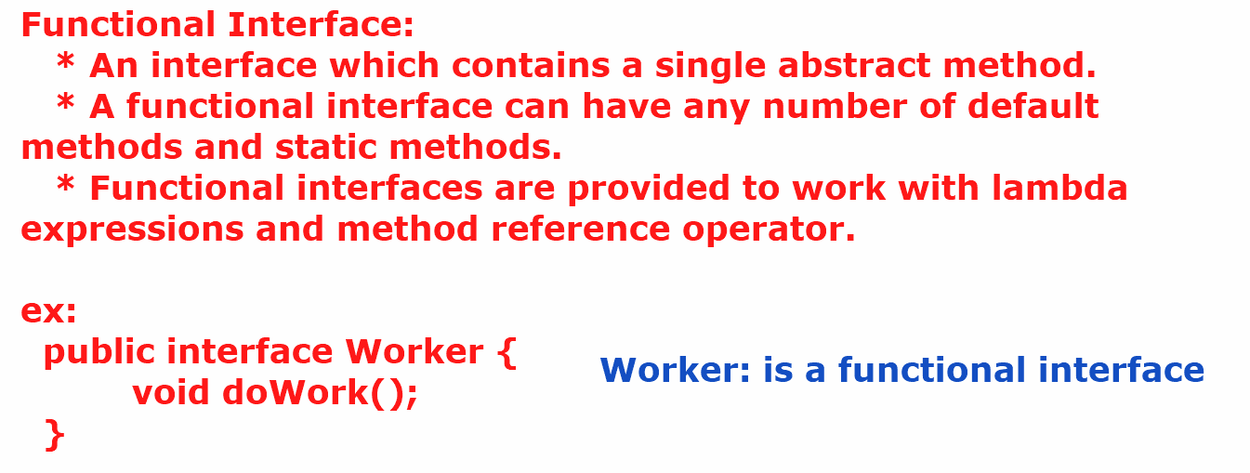
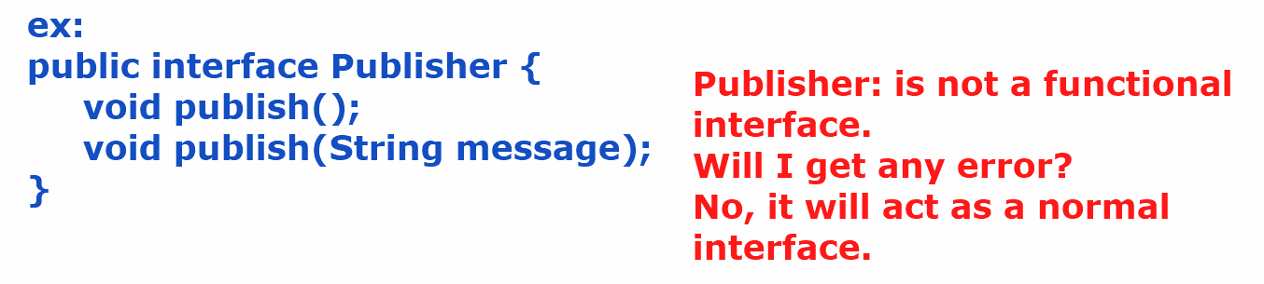
- If you want to get a compile-time error, when an interface contains more than one abstract method then add @FunctionalInterface annotation before that interface.
ex:
@FunctionalInterface
public interface Publisher {
void publish();
default void publish(String message) {
System.out.println(message);
}
default void publish(String message, int number) {
System.out.println(message+ " " + number);
}
}

- In a functional inteface, if we add any java.lang.Object class method as an abstract method, but still it will be a fucntional interface only.
ex:
@FunctionalInterface
public interface Publisher {
void publish();
boolean equals(Object obj);
int hashCode();
}

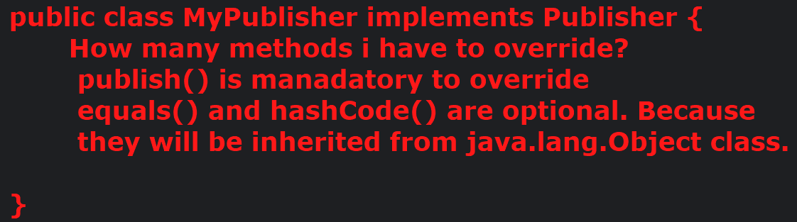

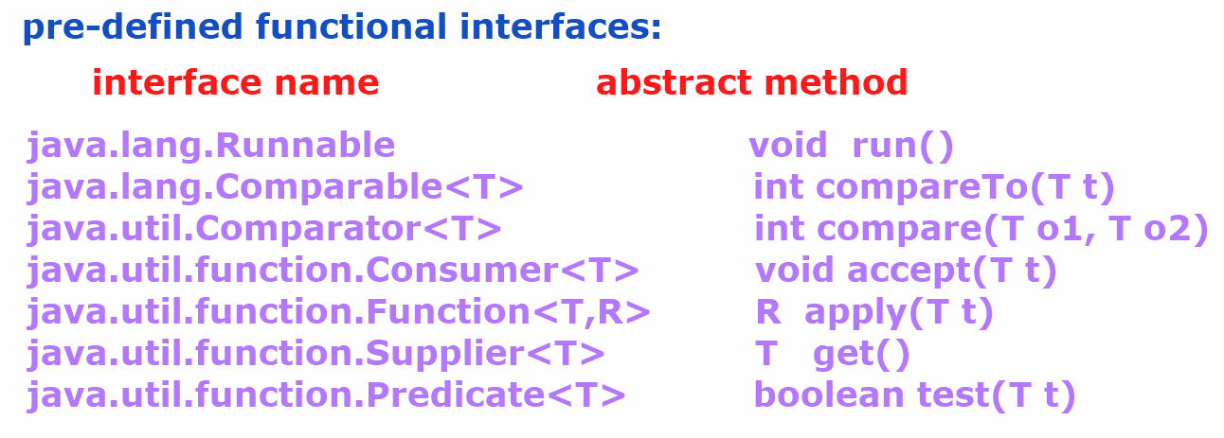
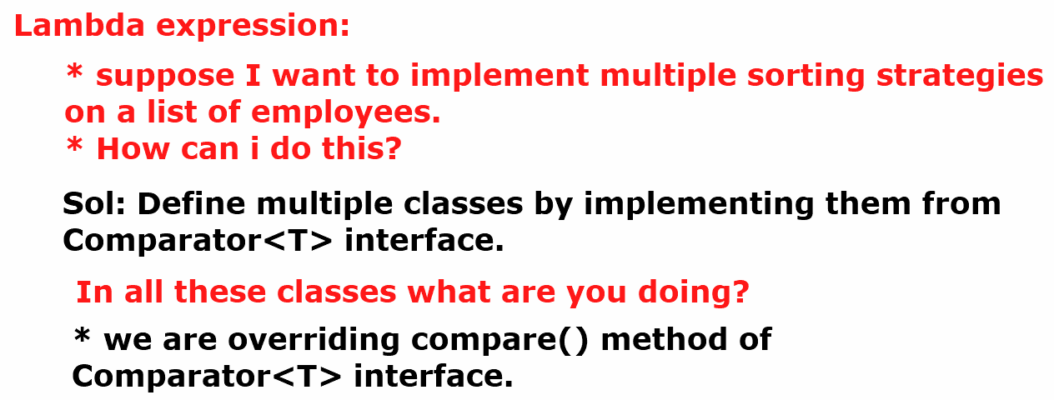
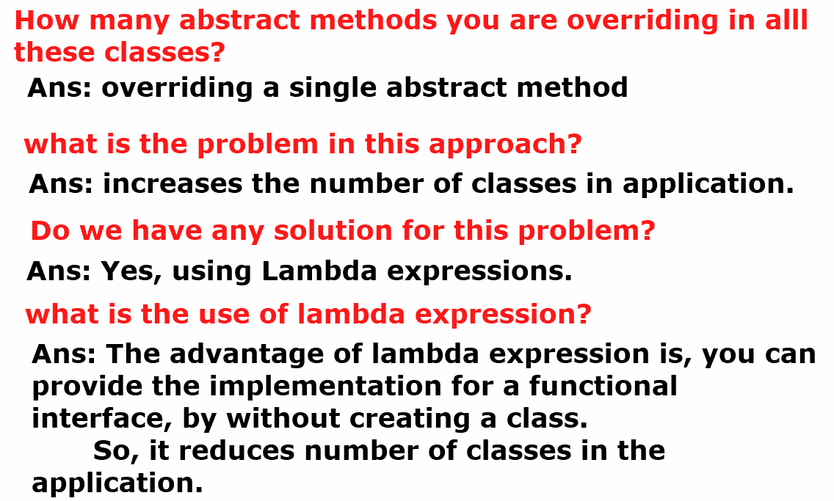
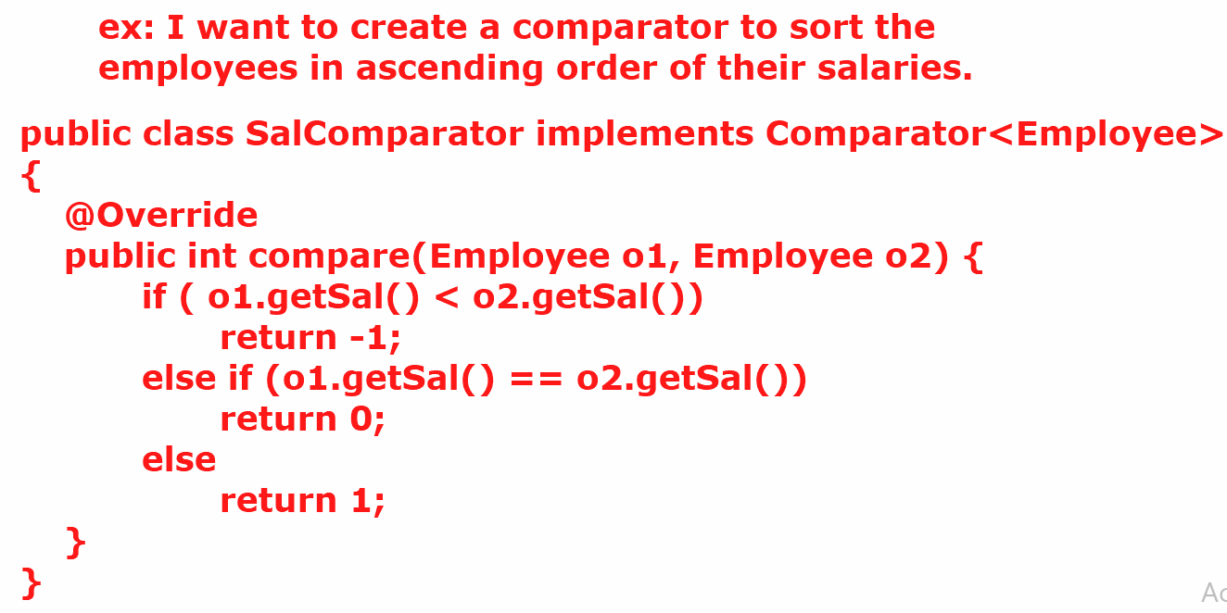
employeesList.sort(new SalComparator());
How can I sort the list of employees by using lambda expression, without a creating a comparator class.
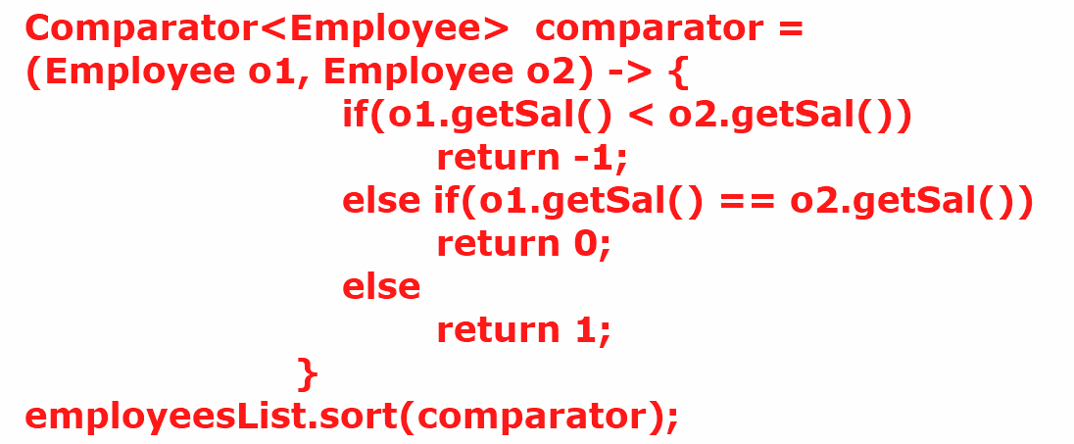
- To write a lambda expression, the syntax is
(arguments) -> body;
- The arguments in this lambda expression should match with the arguments of the abstract method of the functional interface.
- The body of the lambda expression should match with the return type of the abstract method.
- If the number of arguments in lambda expression are zero or more than one then the arguments must be enclosed with in the parenthesis.
- If there is a single argument then parenthesis is optional.
- Data type for the arguments is optional. But don’t specify the type for one, and not for the others. It will generate compile-time error.
example on how to use lambda expression:
@FunctionalInterface
public interface Formatter {
String format(String s1, String s2);
}

public class Main {
public static void main(String[] args) {
// Formatter fr = (s1,s2) -> s1.concat(s2) ;
doWork((s1,s2) -> s1.concat(s2));
doWork((s1,s2) -> s1.toUpperCase().concat(s2.toUpperCase()));
}
private static void doWork(Formatter formatter) {
System.out.println(formatter.format("Spring", "Boot"));
}
}

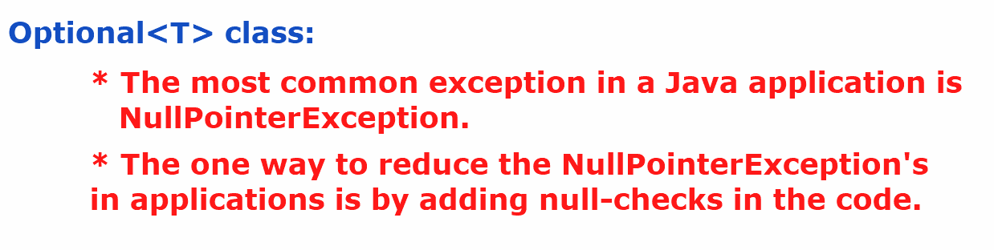
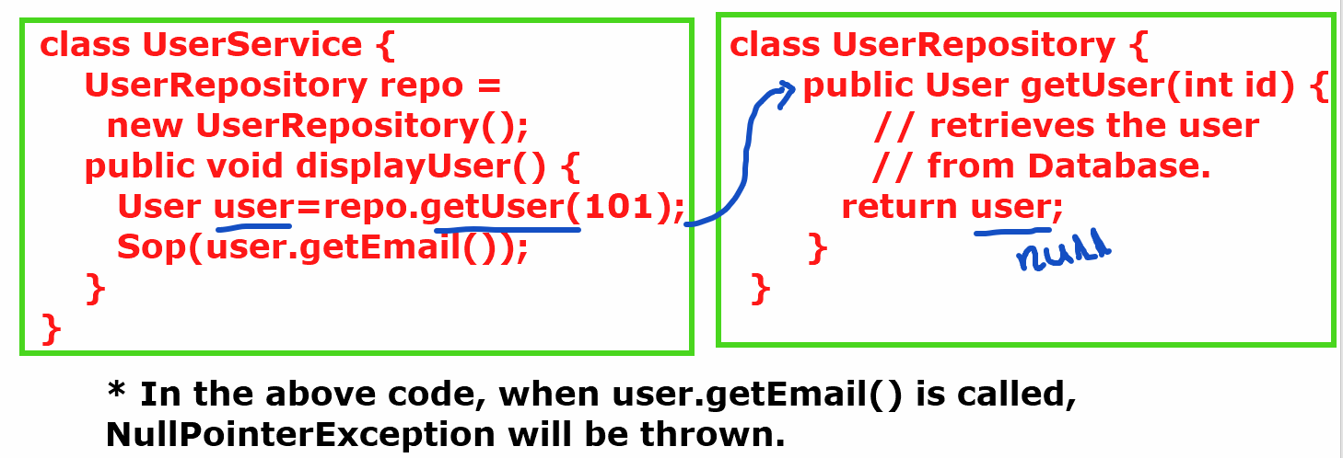
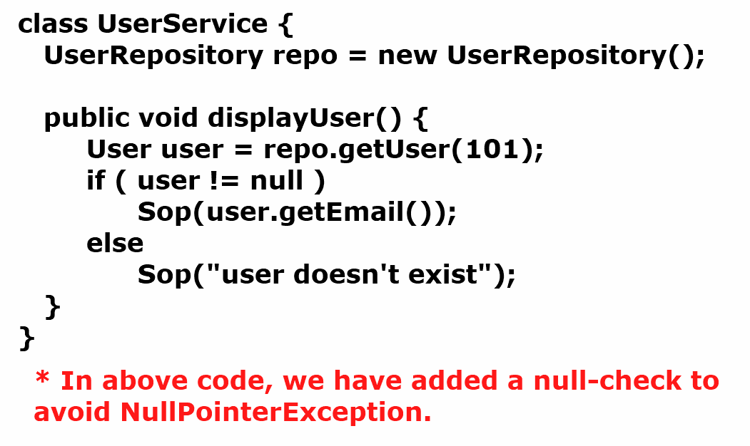
- If more null-checks are added to the code, then the code becomes more complex and it kills the readability of the code.
- So, Optional class is provided in Java8, to reduce the null-checks and also to reduce the NullPointerExceptions.
what is Optional class object?
Ans: Optional class object is a container object, which may or may not contain non-null value.
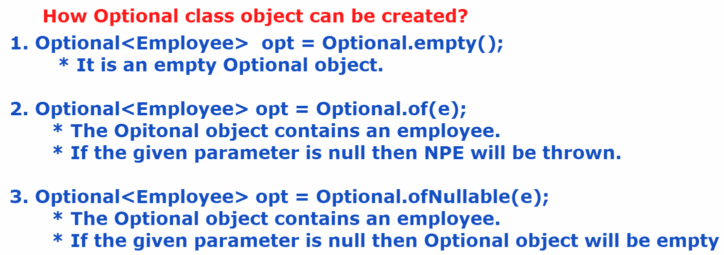
Employee.java
package com.example.model;
public class Employee {
private int empno;
private String ename;
private double sal;
public Employee(int empno, String ename, double sal) {
this.empno = empno;
this.ename = ename;
this.sal = sal;
}
public int getEmpno() {
return empno;
}
public void setEmpno(int empno) {
this.empno = empno;
}
public String getEname() {
return ename;
}
public void setEname(String ename) {
this.ename = ename;
}
public double getSal() {
return sal;
}
public void setSal(double sal) {
this.sal = sal;
}
@Override
public String toString() {
return "Employee{" + "empno=" + empno + ", ename=" + ename + ", sal=" + sal + '}';
}
}

EmployeeRepository.java
package com.example.repository;
import com.example.model.Employee;
import java.util.ArrayList;
import java.util.List;
import java.util.Optional;
public class EmployeeRepository {
List<Employee> employees = new ArrayList<>();
public EmployeeRepository() {
employees.add(new Employee(7189,"King",4000));
employees.add(new Employee(7276,"Turner",5000));
employees.add(new Employee(7788,"Scott",6000));
}
public Optional<Employee> getEmployeeById(int empno) {
for (Employee employee : employees) {
if (employee.getEmpno() == empno) {
return Optional.of(employee);
}
}
return Optional.empty();
}
}

EmployeeService.java
package com.example.service;
import com.example.model.Employee;
import com.example.repository.EmployeeRepository;
import java.util.Optional;
public class EmployeeService {
EmployeeRepository repo = new EmployeeRepository();
public void displayEmployee(int empno) {
Optional<Employee> opt = repo.getEmployeeById(empno);
// opt.ifPresent(e -> System.out.println(e.toString()));
if (opt.isPresent()) {
Employee emp = opt.get();
System.out.println(emp.toString());
}
else {
System.out.println("No employee with such id exists");
}
}
}

Main.java
package com.example.main;
import com.example.service.EmployeeService;
public class Main {
public static void main(String[] args) {
EmployeeService service = new EmployeeService();
service.displayEmployee(7788);
}
}

Methods of Optional<T> class:
--------------------------
1. isPresent() : If value is present in the Optional object then returns true. Otherwise, returns false.

2. get() : Returns the value present in the Optional object.
ex:
Optional<String> opt = Optional.ofNullable(“Hello World”);
if(opt.isPresent()) {
String str = opt.get();
System.out.println(str);
}

3. ifPresent(Consumer<T> consumer) : Executes the given action, if the value is present in the Optional object. Otherwise, do’s nothing.
. This method accepts Consumer object as parameter.
. Consumer is a functional interface, so we can pass lambda expression.
ex:
Optional<String> opt = Optional.ofNullable(“Hello World”);
opt.ifPresent( str -> System.out.println(str) );

4. orElse(T another): if the Optional contains value, it returns that value. If it is empty then returns the another value provided as parameter.
ex1:
Optional<String> opt = Optional.ofNullable(“Hello world”);
String result = opt.orElse(“Bye world”);
System.out.println(result); //output: Hello world
ex2:
Optional<String> opt = Optional.empty();
String result = opt.orElse(“Bye world”);
System.out.println(result); //output: Bye world

5. orElseThrow(): If the Optional contains a value, then returns that value. If it is empty, then throws NoSuchElementException.
ex1:
Optional<String> opt = Optional.ofNullable(“Hello world”);
String result = opt.orElseThrow();
System.out.println(result); //output: Hello world

ex2:
Optional<String> opt = Optional.empty();
String result = opt.orElseThrow(); // throws NoSuchElementException
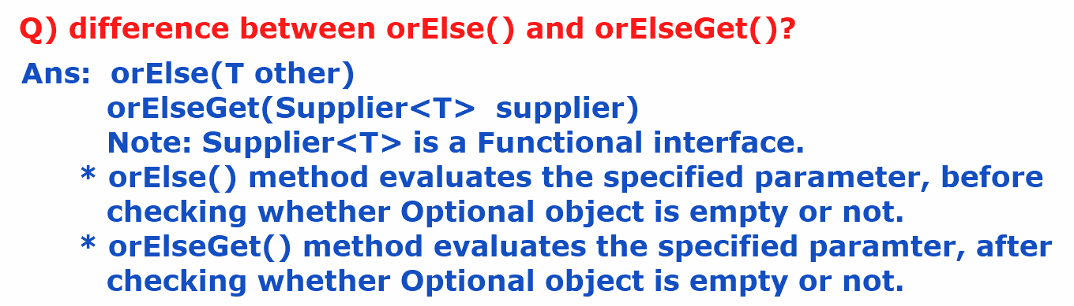

ex:
Employee emp = opt.orElse(new Employee(0, null, 0.0));
Employee emp = opt.orElseGet( () -> new Employee(0, null, 0.0));

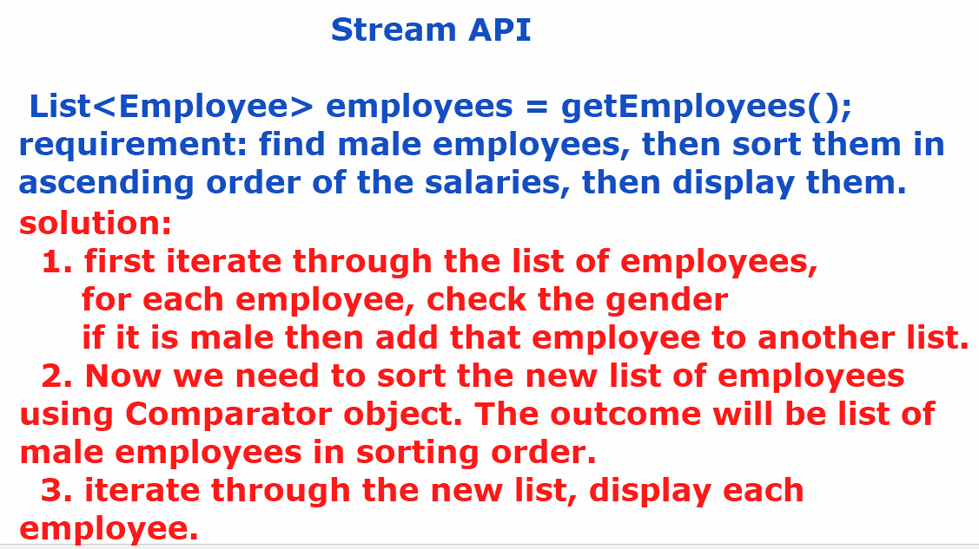
- Before Java8, to perform any processing operations on a collection object, we have to iterate through the collection object, with an Iterator or for each loop and we should define some if conditions to process them.
- This leads to more amount of code. So, the code is hard to understand and increase the complexity.
- In Java, Collection and Stream objects are used for different purposes.
- Collection object is used to store the elements, and a Stream object is used to perform processing operations on the elements.
creating a Stream object:

1. we can a Stream for a Collection object.
Stream<Employee> stream = employeesList.stream();

2. we can create a Stream for an array.
Stream<Integer> stream = Arrays.stream(arr);

3. we can create a Stream object for raw values.
Stream<String> stream = Stream.of(“Tom”, “john”, “Jack”);

4. we can create an empty stream object.
Stream<Void> stream = Stream.empty();

- A stream operations are two types.
1.intermediate operations
2.terminal operations.
* intermediate operation means, it transforms a stream to another stream.
* terminal operation means, which produces the end result.
example:

Stream<Employee> stream1 = employeesList.stream();
Stream<Employee> stream2 = stream1.filter( e -> e.getSal() > 1000);

long count = stream2.count();
- Here, filter() is an intermediate operation and count() is a terminal operation.

filter, map and sorted:
----------------------
- The filter, map, and sorted methods are three fundamental intermediate operations that can be chained together to perform complex data transformations.
- The filter() method is used to select elements from a stream that satisfy a given predicate.
- If the predicate returns true for an element, the element is included in the new stream; otherwise, it's discarded.
- example:
List<Integer> numbers = Arrays.asList(1, 2, 3, 4, 5, 6, 7, 8, 9, 10);
List<Integer> evenNumbers = numbers.stream().filter(n -> n % 2 == 0) .collect(Collectors.toList());
System.out.println(evenNumbers);
- The map() method is used to transform each element of a stream into another object.
- It applies a function to each element, producing a new stream of the results.
- The type of the elements in the new stream can be different from the original stream.
- example:
List<Integer> numbers = Arrays.asList(1, 2, 3, 4, 5);
List<Integer> squares = numbers.stream().map(n -> n * n) .collect(Collectors.toList());
System.out.println(squares);
- The sorted() method is used to sort the elements of a stream. It returns a new stream with the elements sorted according to a natural order or a custom Comparator.
- example:
List<Integer> numbers = Arrays.asList(5, 2, 8, 1, 9);
List<Integer> sortedNumbersDesc = numbers.stream() .sorted(Comparator.reverseOrder()).collect(Collectors.toList()); System.out.println(sortedNumbersDesc);
- Stream API has the ability to chain these intermediate operations. Each intermediate operation returns a new Stream, allowing multiple operations to be combined into a single, readable pipeline.
- example:
List<Integer> numbers = Arrays.asList(1, 2, 3, 4, 5, 6, 7, 8, 9, 10);
List<Integer> result = numbers.stream().filter(n -> n % 2 == 0)
.map(n -> n * n).sorted().collect(Collectors.toList());
System.out.println(result);

Difference between map and flatMap:
----------------------------------
The map() method transforms each element of a stream by applying a function to it, returning a new stream containing the results.
It's used when you want to perform a one-to-one transformation, meaning each input element produces exactly one output element.
Example: Suppose you have a list of strings and you want to get the length of each string.
List<String> words = Arrays.asList("hello", "world", "java");
List<Integer> lengths = words.stream() .map(String::length) .collect(Collectors.toList());
System.out.println(lengths);

The flatMap() method is used when the function applied to each element of the stream returns a stream and you want to flatten these individual streams into a single stream. It performs a one-to-many transformation, where each input element can produce zero, one, or multiple output elements.
Example: Suppose you have a list of lists of integers, and you want to get a single list containing all integers from all inner lists.
List<List<Integer>> listOfLists = Arrays.asList(
Arrays.asList(1, 2),
Arrays.asList(3, 4, 5),
Arrays.asList(6) ); List<Integer> allNumbers = listOfLists.stream() .flatMap(Collection::stream).collect(Collectors.toList()); System.out.println(allNumbers);

public class EmployeeService {
public static List<Employee> getEmployees(){
List<Employee> employees = new ArrayList<>();
employees.add(new Employee(7078, "Blake", 5000, "Male", 10));
employees.add(new Employee(7156, "Turner", 9000, "Male", 20));
employees.add(new Employee(7267, "Sophia", 6000, "Female", 10));
employees.add(new Employee(7299, "King", 3000, "Male", 30));
employees.add(new Employee(7435, "Emma", 4000, "Female", 20));
employees.add(new Employee(7180, "Mary", 5000, "Female", 30));
employees.add(new Employee(7788, "Scott", 8000, "Male", 10));
employees.add(new Employee(7923, "Allen", 7000, "Male", 20));
employees.add(new Employee(7798, "Kathey", 5000, "Female", 10));
return employees;
}
// Get employees with sal > given salary
public List<Employee> getEmployeesBySalGreaterThan(double sal) {
/*
Stream<Employee> empStream = getEmployees().stream();
Stream<Employee> filterdStream = empStream.filter( (e) -> e.getSal() > sal);
List<Employee> filterdEmployees = filterdStream.toList();
return filterdEmployees;
*/
return getEmployees()
.stream()
.filter(e -> e.getSal() > sal)
.toList();
}
// Get the names of employees
public List<String> getEmployeesNames(){
return getEmployees()
.stream()
.map(Employee::getEname)
.toList();
}
// Get the female employees
public List<Employee> getFemaleEmployees() {
return getEmployees()
.stream()
.filter(e -> e.getGender().equalsIgnoreCase("FEMALE"))
.toList();
}
}

public class Main {
public static void main(String[] args) {
EmployeeService employeeService = new EmployeeService();
/*
List<Employee> employees = employeeService.getEmployeesBySalGreaterThan(9000);
employees.forEach(System.out::println);
*/
/*
List<String> employeeNames = employeeService.getEmployeesNames();
employeeNames.forEach(System.out::println);
*/
List<Employee> femaleEmployees = employeeService.getFemaleEmployees();
femaleEmployees.forEach(System.out::println);
}
}

// Get the highest paid employee
public Optional<Employee> getHighestPaidEmployee() {
return getEmployees()
.stream()
.max(Comparator.comparing(Employee::getSal));
}
// Get the top 3 paid employees
public List<Employee> getTop3PaidEmployees() {
return getEmployees()
.stream()
.sorted(Comparator.comparing(Employee::getSal).reversed())
.limit(3)
.toList();
}
// Get the avg salary of employees
public double getAverageSalary() {
return getEmployees()
.stream()
.mapToDouble(e -> e.getSal())
.average()
.getAsDouble();
}
// Get the sum of a list of integers using stream
public int getSumOfIntegers() {
List<Integer> numbers = Arrays.asList(4,2,9,0,1);
return numbers
.stream()
.mapToInt(i -> i.intValue())
.sum();
}
// Check all employees have sal > 3000
public boolean check() {
return getEmployees()
.stream()
.allMatch(e -> e.getSal() > 3000);
}
// Group the employees by their department
public Map<Integer, List<Employee>> getEmployeesByDepartment() {
return getEmployees()
.stream()
.collect(Collectors.groupingBy(e -> e.getDeptno()));
}
// Count the employees group by department
public Map<Integer, Long> getEmployeesCountByDepartment() {
return getEmployees()
.stream()
.collect(Collectors.groupingBy(Employee::getDeptno, Collectors.counting()));
}
// partition the employees by sal > 7000
public Map<Boolean, List<Employee>> getEmployeesByPartition() {
return getEmployees()
.stream()
.collect(Collectors.partitioningBy(e ->e.getSal() > 7000));
}

public class Main {
public static void main(String[] args) {
EmployeeService employeeService = new EmployeeService();
/*
List<Employee> employees = employeeService.getEmployeesBySalGreaterThan(9000);
employees.forEach(System.out::println);
*/
/*
List<String> employeeNames = employeeService.getEmployeesNames();
employeeNames.forEach(System.out::println);
*/
/*
List<Employee> femaleEmployees = employeeService.getFemaleEmployees();
femaleEmployees.forEach(System.out::println);
*/
/*
Optional<Employee> optional = employeeService.getHighestPaidEmployee();
optional.ifPresent(System.out::println);
*/
/*
List<Employee> employees = employeeService.getTop3PaidEmployees();
employees.forEach(System.out::println);
*/
/*
double averageSalary = employeeService.getAverageSalary();
System.out.println("Average Salary: " + averageSalary);
*/
/*
int sum = employeeService.getSumOfIntegers();
System.out.println(sum);
*/
/*
boolean flag = employeeService.check();
System.out.println(flag);
*/
/*
Map<Integer, List<Employee>> employeesByDepartment = employeeService.getEmployeesByDepartment();
employeesByDepartment.forEach((key, value) -> {
System.out.println(key + " : " + value);
});
*/
/*
Map<Integer, Long> countMap = employeeService.getEmployeesCountByDepartment();
countMap.forEach((k,v)->{
System.out.println(k + " : " + v);
});
*/
Map<Boolean, List<Employee>> employeesByPartition = employeeService.getEmployeesByPartition();
List<Employee> employees = employeesByPartition.get(true);
System.out.println("Employees by partition which satisfies the predicate");
employees.forEach(System.out::println);
List<Employee> employees1 = employeesByPartition.get(false);
System.out.println("Employees by partition which don't satisfies the predicate");
employees1.forEach(System.out::println);
}
}

parallelStream() method:
- parallel stream is a feature of the Stream API.
- It will process the elements of a collection parallelly on multiple CPU cores.
- Parallel stream will split the data into multiple data chunks,
executes each chunk on a separate cpu core and then joins the results of multiple cpu cores and returns the final result.
- parallel stream internally Fork/Join Framework(feature from Java7+).
A parallel stream can be created by calling parallelStream() on a collection object.
// stream vs parallel stream
public void displayEmployees() {
long start = System.currentTimeMillis();
getEmployees()
.stream()
.filter(e -> e.getSal() > 5000)
.forEach(System.out::println);
long end = System.currentTimeMillis();
System.out.println("Time taken by stream: " + (end - start) + " milliseconds");
System.out.println("========================================");
long st = System.currentTimeMillis();
getEmployees()
.parallelStream()
.filter(e -> e.getSal() > 5000)
.forEach(System.out::println);
long et = System.currentTimeMillis();
System.out.println("Time taken by parallelStream: " + (et - st) + " milliseconds");
}

Date/Time API:
- Before Java8 version, we have java.util.Date and java.util.Calendar classes to work with data and time values.
- The problem with these classes is, they are mutable objects. So, in mulithreaded applications, if one thread changes the value, then it effects on other thread. This is a bug.
- The other issue is, the year starts from 1900, not from 0.
- For example, if I create,
- Date d = new Date(120, 0, 21);
- then, it represents the year 2020, not 120.
- So, Java 8 has provided, new classes to work with Date and Time values in java.time package.

- LocalDate class
- LocalTime class
- LocalDateTime class
- ZonedDateTime class
- Period class

For example,
LocalDate today = LocalDate.now(); //The LocalDate object is
created with current system date.

LocalDate expDate = LocalDate.of(2025, 11, 30);

- LocalDate, LocalTime, and LocalDateTime classes objects are immutable objects. So, if you make any changes then new objects are created with results.
ex:
LocalDate date1 = LocalDate.of(2025, 1, 31);
LocalDate date2 = date1.plusDays(3);
S.o.p(date1); //output: 2025-01-31
S.o.p(date2); //output: 2025-02-3

Finding the difference between two LocalDate instances: LocalDate mfg = LocalDate.of(2025, 8, 15);
LocalDate exp = LocalDate.of(2028, 02, 27);
long days = ChronoUnit.DAYS.between(mfg, exp);
System.out.println("The days between " + mfg + " and " + exp + " is " + days);
long months = ChronoUnit.MONTHS.between(mfg, exp);
System.out.println("The months between " + mfg + " and " + exp + " is " + months);

creating LocalDateTime and ZonedDateTime instances:
LocalDateTime localDateTime = LocalDateTime.now();
System.out.println(localDateTime);
ZonedDateTime zonedDateTime = ZonedDateTime.now();
System.out.println(zonedDateTime);
ZonedDateTime newYorkDateTime = ZonedDateTime.now(ZoneId.of("America/New_York"));
System.out.println(newYorkDateTime);
ZonedDateTime sydneyDateTime = ZonedDateTime.now(ZoneId.of("Australia/Sydney"));
System.out.println(sydneyDateTime);
output:
2025-09-12T09:43:45.702618300
2025-09-12T09:43:45.705619800+05:30[Asia/Calcutta]
2025-09-12T00:13:45.708621900-04:00[America/New_York]
2025-09-12T14:13:45.713919400+10:00[Australia/Sydney]

Getting all the available zone id’s:
Set<String> availableZoneIds = ZoneId.getAvailableZoneIds();
availableZoneIds.stream().sorted().forEach(System.out::println);

Period class:
LocalDate dt1 = LocalDate.of(2024, 8, 31);
LocalDate dt2 = LocalDate.of(2025, 1, 1);
Period period = Period.between(dt1, dt2);
System.out.println("difference between " + dt1 + " and " + dt2 + " in Years = " + period.getYears());
System.out.println("difference between " + dt1 + " and " + dt2 + " in Months = " + period.getMonths());
System.out.println("difference between " + dt1 + " and " + dt2 + " in Days = " + period.getDays());
output:
difference between 2024-08-31 and 2025-01-01 in Years = 0
difference between 2024-08-31 and 2025-01-01 in Months = 4
difference between 2024-08-31 and 2025-01-01 in Days = 1
Base64 class:
- Base64 class is provided to converted a binary data to text format, or a text from one format to another.
- Mostly Base64 class is used to convert an image to a text format(encoding) and text to image(decoding).
- Base64 has two nested classes,
- Base64.Encoder and
- Base64.Decoder
Base64 class has provided static methods to create Encoder and Decoder instances.
Base64.Encoder encoder = Base64.getEncoder();
Base64.Decoder decorder = Base64.getDecoder();
example:
public class Test {
public static void main(String[] args) {
// encode a text to encoded text
String str = "Java8 has more features";
byte[] bytes = str.getBytes();
Base64.Encoder encoder = Base64.getEncoder();
String encoded = encoder.encodeToString(bytes);
System.out.println("original: " + str);
System.out.println("encoded: " + encoded);
System.out.println("=========================");
// decode encoded text to normal text
Base64.Decoder decoder = Base64.getDecoder();
byte[] decoded = decoder.decode(encoded);
String decodedString = new String(decoded);
System.out.println("decoded: " + decodedString);
}
}

example:
// image to text format and text to image format
// convert image to text format.
String imagePath = "C:\\Users\\WINDOWS\\Downloads\\iphone16.jfif";
File file = new File(imagePath);
FileInputStream fis = new FileInputStream(file);
byte[] b = new byte[(int) file.length()];
fis.read(b);
fis.close();
Base64.Encoder encoder = Base64.getEncoder();
String encoded = encoder.encodeToString(b);
System.out.println(encoded);
System.out.println("=========================================");
// convert encoded text to image.
Base64.Decoder decoder = Base64.getDecoder();
byte[] decoded = decoder.decode(encoded);
String imagePath2 = "C:\\Users\\WINDOWS\\Downloads\\iphone116.jfif";
FileOutputStream fos = new FileOutputStream(imagePath2);
fos.write(decoded);
fos.close();
System.out.println("encoded text is decoded to an image");

CompletableFuture<T> class:

- Executor Framework was added in Java5, to simplify the multithreading and to manage and control the thread execution using a high-level API.
- Before Java 5, programmers have to manually create and manage the threads using Thread class and Runnable interface.
- The problems here are like, developers have to create, start and stop the threads, developers have to take care of synchrnonization manually and creating too many threads will consume more system resources.
- So, Java 5 has introduced Executor Framework, where a developer has to define the task and has to submit it to the Executor Framework. The rest of the work like creating the threads, executiong the threads, synchronization, etc.. will be taken care by Executor Framework only.
- The key components of Executor Framework are,
- 1. Executor interface -- Basic interface
- 2. ExecutorService interface – extends Executor interface
- 3. Executors class – utility class, creates ExecutorService instance.
Types of Executors:
1. ExecutorService service = Executors.newSingleThreadExecutor();
* creates a single thread, processes the tasks sequentially.
* Suppose, if 2 tasks are submitted to the ExecutorService, then first one thread is created to execute task1, after that thread dies, another thread is created to execute task2.
2. ExecutorService service = Executors.newFixedThreadPool(n);
* creates a fixed number of threads.
* It is good for executing controlled number of parallel tasks.
3. ExecutorService service = Executors.newCachedThreadPool();
* creates new threads as needed and also reuses existing threads.

How to submit my task to the ExecutorService?
1. void execute(Runnable runnable)
2. Future submit(Callable callable)
Runnable and Callable are the functional interfaces.
Runnable’s abstract method -- void run();
Callable’s abstract method -- V call() throws Exception.
- Runnable doesn’t return the result and doesn’t throw Exception. But Callable returns the computed result, if unable to compute then throws Exception.
- Future<T> is an interface from Java 5+ and it is to hold the result of a task, going to be generated in future.
// The below code is to understand how to submit a task to the executor and how to retrieve the result from Future object.
public class Test {
public static void main(String[] args) throws ExecutionException, InterruptedException {
// create executor
ExecutorService executor = Executors.newFixedThreadPool(5);
// define the task
Callable<String> callable = () -> {
TimeUnit.SECONDS.sleep(10);
return "Hello World";
};
System.out.println("Main thread has started its work....");
Future<String> future = executor.submit(callable);
System.out.println("Main thread is continuing its work....");
System.out.println("Main thread has finished its work....");
String message = future.get();
System.out.println("The result of the submitted task : " + message);
executor.shutdown();
}
}

- CompletableFuture is a class provided in Java8, which is an implementation of Future interface.
- A Future represents the result of an asynchronous task.
- CompletableFuture allows chaining of asynchronous operations.
- For example, consider a scenario where you need to fetch a user id and then, using that id, you need to fetch user details. Here the tasks are dependen, so we can chain these tasks with CompletableFuture’s chaining methods.
- In CompletableFuture, you no need to create ExecutorService object to submit the task to it. You can directly the submit the task to CompletableFuture.
- ex:
CompletableFuture<UserDetails> userDetailsFuture = CompletableFuture.supplyAsync( () -> fetchUserDetails());

CompletableFuture<List<Order>> ordersFuture = CompletableFuture.supplyAsync( () -> fetchOrders());

UserDetails userDetails = userDetailsFuture.join();
List<Order> orders = ordersFuture.join();

