Microservices
Monolithic application:
- A monolithic application means, all the components like user interface, business logic, data access logic are tightly coupled together and packaged together into a single war/jar file for deployment.
- A monolithic application is built as a single codebase application.
- All the software systems were started as monolithic applications.
- A monolithic application is deployed as a single entity and all the components will share the same CPU and a single Database.
disadvantages:
- If you need to scale any part of the application, you have to scale the entire application on to the multiple servers, which is inefficient and costly.
- If the codebase grows, it becomes more complex to understand and it can slow down deployment cycles.
- A smalle change requires the whole application redeployment, which can lead to longer downtime of the application.
- The entire application has to use a single technology and it is difficult to adopt new technologies.
Note: The applications like Amazon, Flipkart, Facebook, Netflix were started as Monolithic applications only earlier.
Microservices:
* Microservices is a new architectural style of developing the modern large scale applications, by decomposing a large application into a collection of small, independent services with single responsibility principle.
* Microservices are distributed systems, it means the application is a collection of services, where each service is running at different location over the internet.
Advantages:
- Each service can be developed, deployed and managed independently.
- A service can be independently scaled onto mulitple servers, if it is experiencing heavy traffic.
- Different services can be built using different technology stacks. So that, a team can choose the best for developing a service. This is called Polyglot applications.
- Each service can manage its own data.
- If one service fails, it won’t bringdown the entire application. Other services can continue to function.

- While majority of the large scale systems, like Amazon, flipkart, Netflix, Uber, Facebook, etc.. are migrated from monolithic to microservices, but still some mid-sized and small applications are running as monolithic in the industry.

- For example, a local e-commerce platform like handicraft emporium is monolithic application. It manages the products, orders, payments, inventory, etc.. in a single codebase application.

- For example, Osmania university student portal application is a monolithic application. It manages admissions, course registrations, fee payments, attendence tracking, etc.. in a single codebase application.

example:
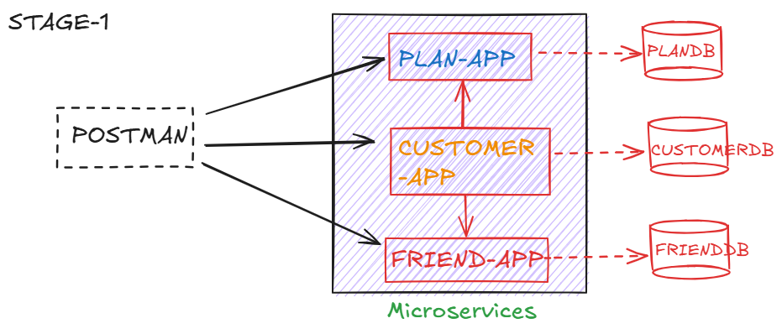
PLAN-APP:
- This service exposes API endpoints to fetch plan details.

GET /plans : returns all the existing plans
GET /plans/{id} : return the details of a specific plan.
- We create a table PLAN_DETAILS, with columns,
PLAN_ID
PLAN_NAME
DESCRIPTION
VALIDITY.
- insert some sample records into the table.
- open mysql workbench and execute the below commands.

- CREATE DATABASE plandb;
- USE plandb;
- CREATE TABLE PLAN_DETAILS (
- PLAN_ID VARCHAR(20) PRIMARY KEY,
- PLAN_NAME VARCHAR(50),
- DESCRIPTION VARCHAR(50),
- VALIDITY VARCHAR(30)
- );

- INSERT INTO PLAN_DETAILS VALUES
- ('PLAN-399', 'DATA RECHARGE', '2GB/DAY, 100SMS/DAY', '28 DAYS'),
- ('PLAN-789', 'EASY RECHARGE', '2.5GB/DAY, 200SMS/DAY', '56 DAYS'),
- ('PLAN-999', 'VALIDITY RECHARGE', '3GB/DAY, 300SMS/DAY', '72 DAYS'),
- ('PLAN-299', 'TOPUP RECHARGE', '1GB/DAY, 100SMS/DAY', '24 DAYS'),
- ('PLAN-1099', 'DATA RECHARGE', '3.5GB/DAY, 400SMS/DAY', '60 DAYS');

- COMMIT;
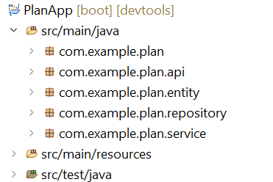
https://github.com/ShekherJava/PlanApp.git
FRIEND-APP:
- This service exposes API endpoints to add a friend contact and to fetch the friends contacts of a customer.

POST /friend/save : adds a friend contact of a customer
GET /friend/{phoneNumber} : returns friends contacts of a customer.

- OPEN mysql-workbench and exectue the below commands.
CREATE DATABASE frienddb;
use frienddb;
CREATE TABLE FRIEND(
ID INT PRIMARY KEY AUTO_INCREMENT,
PHONE_NUMBER long,
FRIEND_NUMBER long,
FRIEND_NAME VARCHAR(50)
);

INSERT INTO FRIEND(PHONE_NUMBER, FRIEND_NUMBER,FRIEND_NAME) VALUES
(1001001001, 8008008008, 'MILLER'),
(1001001001, 9009009009, 'JOHN'),
(2002002001, 5005005005, 'SOPHIA'),
(1001001001, 6902991654, 'MARY'),
(2002002001, 7834422169, 'CLARK'),
(2002002001, 8677456210, 'WOOD');

COMMIT;
SELECT * FROM FRIEND;

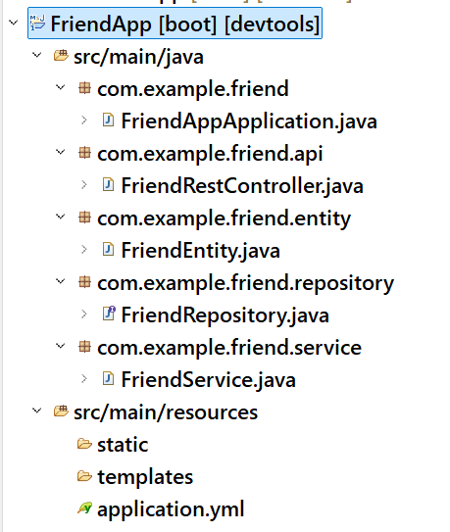

https://github.com/ShekherJava/FriendApp.git

CUSTOMER-APP
- This service exposes API endpoints to register a customer, login a customer and fetch the profile of a customer.

POST /customer/register: to register a customer
POST /customer/login : to login a customer
GET /customer/profile/{phoneNumber}: to fetch the customer
profile.
- open mysql workbench and execute the below commands.
CREATE DATABASE customerdb;
use customerdb;

CREATE TABLE CUSTOMER(
PHONE_NUMBER BIGINT,
USERNAME VARCHAR(50),
PASSWORD VARCHAR(60),
EMAIL VARCHAR(100),
PLAN_ID VARCHAR(40),
primary key(PHONE_NUMBER)
);

INSERT INTO CUSTOMER VALUES
(1001001001, 'ABC', 'abc@123', 'abc@GMAIL.COM', 'PLAN-789'),
(2002002001, 'XYZ', 'xyz@321', 'xyz@GMAIL.COM', 'PLAN-1099');

commit;
SELECT * FROM CUSTOMER;

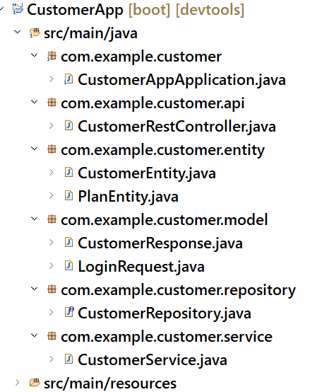
https://github.com/ShekherJava/CustomerApp.git
Spring Cloud
- Spring Cloud is a collection of projects which are ready-to-use solutions to the challenges that we are going to face in the microservices, by without implementing the solutions by the developers manually.
- The challenges that Spring Cloud can address:
- we might have hundreds of microservices, each with its own configuration. If any changes are required in the configuration then we need to visit each service to modify the configuration. It is very difficult and practically impossible.
solution: Spring Cloud provides centralized configuration management, backed by Git repository.
- When services are deployed dynamically and when they are scaled up or down, the network locations(ipaddress and port) will change. So, a service can not find and communicate with other microservice.
solution: Spring Cloud has provided Spring Cloud Netflix Eureka project, which provides service registration and discovery mechanism.
- If one service fails, then cascading failure will be there on other services. So, it can bring down the entire system.
solution: Spring Cloud Circuit Breaker, which integrates with Resilience4J library, provides a mechanism to prevent cascading failures.
- When a web/mobile client is accessing the backend microsevices, if the network locations are updated then clients can’t access the backend services.
solution: Spring Cloud Gateway provides a single entry point for the clients to access the backend microservices, by routing the requests.
- In microservices, a request can travel across dozens or hundreds of microservices. Debugging issues is a challenging task.
solution: Spring Cloud Sleuth used with Zipkin provides the distributed tracing capabilities.

Spring Cloud Config Server:
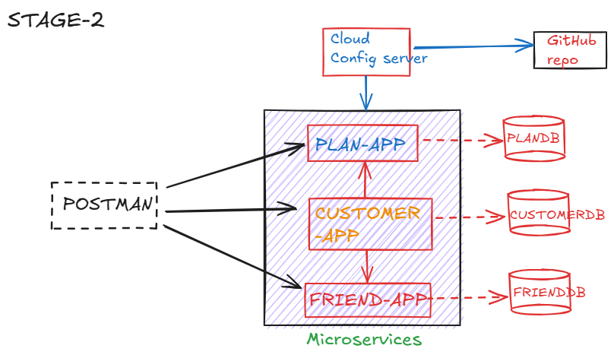
- Our microservices will get the configuration properties from the cloud config server and this config server will load the configuration properties from the github repository.

- create a repository in GitHub.
- create a file application.properties or application.yml in the repository.
- place the common properties in the application.properties or application.yml file.
- create a spring boot project ConfigServerApp with the required dependencies. (Spring Web, Config Server)
- add the git repository url in the properties file of the ConfigServerApp.
(spring.cloud.config.server.git.uri=git repository url)
- add @EnableConfigServer annotation on spring boot main class

Note: To verify whether config server has loaded the configuration properties from the github repository or not, send a request to the below url from POSTMAN or from Browser.
http://localhost:1111/application-default.properties

- In the microservices, do the below chanages.
- remove the common properties from the respective application.yml files of the microservices.
- add a new starter config client to the microservices.
Note: right click on microservice spring add starters choose config client next finish.
- add the below property in the respective application.yml files of the microservices.
spring:
config:
import=optional:configserver:http://localhost:1111

Eureka server (Service Registry):
- In microservices, there is a inter-service communication between one service to another.
- one service may talk to multiple services also.
- In this communication, suppose if host or port of a service is changed(network location), then the other service can’t able communicate to it.
- So, as a solution, we got service registry discovery pattern in microservices.
- In this pattern, each microservice registers with a central server called service registry.
- During registration, the service name(application name), its host and port are registered with the service registry.
- If a service is registered then only it can able to find the other services registered in the registry.
- If one service get redeployed at a different host or port then other services need not worry about it.
- When the service gets redeployed, it would simply updates its information in the service registry.
- So, the other services would discover its updated details through service registry.
steps to create eureka server:
-----------------------------
- add eureka server and dev tools dependencies while creating the project.
- add @EnableEurekaServer at boot start class.
- add the below properties to application.properties file.
spring.application.name=Service_Registry
server.port=8761
eureka.client.register-with-eureka=false
eureka.client.fetch-registry=false
eureka.client.service-url.defaultZone=http://localhost:8761/eureka/

- If you don’t specify server.port=8761, by default eureka server runs on port 8761.
- register-with-eureka=false, prevents the server from registering itself as a client.
- fetch-registry=false, stops the server from trying to fetch the registry, which is unnecessary for the server role.
- service-url.defaultZone defines the URL where Eureka clients can find the Eureka server to register themseleves.
Note: After starting the EurekaServerApp, you can access the Eureka dashboard with the url, http://localhost:8761
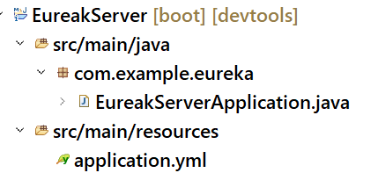
- Download the application from the below url:
https://github.com/ShekherJava/EurekaServer.git
- Do the below changes to the microservices(PlanApp, FriendApp, and CustomerApp).
- In PlanApp, FriendApp and CustomerApp services, add the eureka client dependency and also add @EnableDiscoveryClient on the boot start class.
- In CustomerApp, add @LoadBalanced annotation on the Bean method to make RestTemplate object as a Load balanced object.
ex:
@Bean
@LoadBalanced
public RestTemplate restTemplate() {
return new RestTemplate();
}
- In CustomerRestController class, replace localhost:8081 with PLANAPP and localhost:8082 with FRIENDAPP in the Urls.

Feign client
========================================================
- In a microservices architecture, services frequently need to communicate with each other. Traditionally, you might use RestTemplate or WebClient to make these calls in Spring.
- You have to manually construct the URL’s, handle the request bodies and parsing the responses.
- There may be chances of doing mistakes in URL’s, HTTP methods, data serialization/deserialization.
- If any changes are made in API endpoints, or request/response formats then modifications are required in multiple places.
- To address these issues, Spring Cloud has provided Feign client.
- Feign is a declarative HTTP client developed by Netflix, and Spring Cloud integrates it to simplify RESTful service calls in microservices.
- you declare an interface that represents the remote service's API. Feign then dynamically generates the implementation of that interface at runtime.
- To use feign client to invoke another microservice,
- define an interface with abstract method signatures that map directly to the HTTP endpoints of another service.
- annotate the interface with @FeignClient
example:
@FeignClient( name = "PLANAPP")
public interface PlanServiceClient {

@GetMapping( value = "/plans/{id}")
PlanEntity fetchPlanById(@PathVariable String id);
}

- Feign takes this interface and, behind the scenes, generates the code
- Constructs the HTTP request.
- Sends the request.
- Receives the response.
- Deserializes the response into the specified return type.

- To use feign client in spring boot application,
- 1. add dependency
<dependency>
<groupId>org.springframework.cloud</groupId>
<artifactId>spring-cloud-starter-openfeign</artifactId>
</dependency>
- 2. Add @EnableFeignClients to your boot main application class.
How to start multiple instances of a service?
- disable server.port in the yml file of the service.(ex: FriendApp)
- Suppose, if you want to start 3 instances of FriendApp service, then open 3 command prompts, and execute the below command from the command prompt.
mvn spring-boot:run -Dspring-boot.run.arguments=”—server.port=8071”
mvn spring-boot:run -Dspring-boot.run.arguments=”—server.port=8081”
mvn spring-boot:run -Dspring-boot.run.arguments=”—server.port=8091”
- Suppose, if you want to start 3 instances of FriendApp service, from STS IDE then
Right Click on FriendApp RunAs Run configurations Right click on Spring Boot App at left side new configuration choose project: FriendApp, Main class Arguments tab, under VM arguments, add the below statement
-Dserver.port=8071 run

Note: When you start multiple instances of a service, all the instances are registered with Eureka Registry.
Feign client will load balance the requests automatically onto the multiple instances of a service. Feign client internally uses Spring Cloud Loadbalancer component for load balancing.

- Download the updated services.
- https://github.com/ShekherJava/PlanApp.git
- https://github.com/ShekherJava/CustomerApp.git
- https://github.com/ShekherJava/FriendApp.git

Resilience4J
- Resilience means, adding the capabilities to the application that it can recover quickly from its failures.
- To avoid cascading failures and also to handle the failures gracefully, we have to use resilience4j library.
- Before resilience4j, we had hystrix library and it was developed with the netflix library support.
- In microservices, for a request, a chain of services will communicate.
- When a there is a failure occurred in a single service, then it effects the entire chain.
- So, we need to ensure that the entire chain of microservices should not fail, when there is a failure occurred in one service.
- We need to define a fallback service, so that when actual service is failing, the fallback service should be invoked to get some default values.
- To make a service, quickly recover from its failures, we have to implement circuit breaker pattern.
- circuit breaker will monitor the remote calls and if enough calls fail, then circuit breaker will popup and it prevents the future calls to that service.
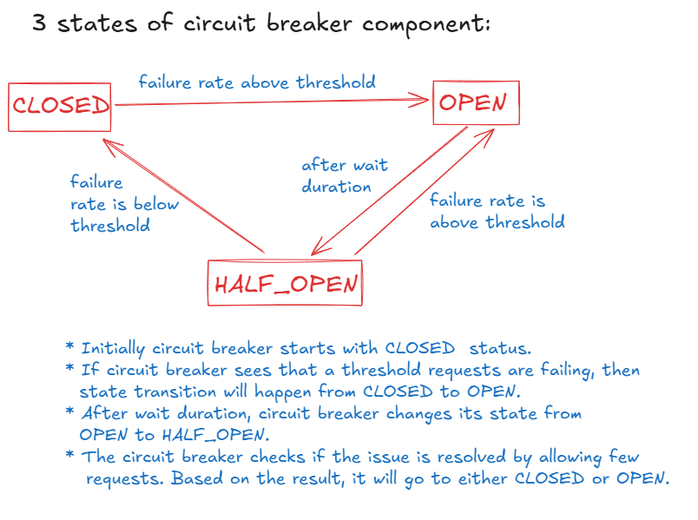
changes to be made in CustomerApp service:
- add the dependency in pom.xml

<dependency> <groupId>org.springframework.cloud</groupId>
<artifactId>spring-cloud-starter-circuitbreaker-resilience4j</artifactId>
</dependency>
- add the below properties to the application.properties file.

resilience4j.circuitbreaker.configs.default.sliding-window-size=6
resilience4j.circuitbreaker.configs.default.failure-rate-threshold=50
resilience4j.circuitbreaker.configs.default.permitted-number-of-calls-in-half-open-state=2
resilience4j.circuitbreaker.configs.default.wait-duration-in-open-state=10000
spring.cloud.openfeign.circuitbreaker.enabled=true

Here, sliding-window-size denotes how many requests that the circuit breaker has to watch initially.

failure-rate-threshold denotes the percentage of requests to be failed, to move the circuit breaker from one state to another state.

wait-duration-in-open-state denotes a milliseconds of time that circuit breaker has to wait to move from open to half open state.

Spring Cloud Gateway:
---------------------
- Suppose, a client application is making REST API calls to back-end microservices.
- The direct communication between clients and the microservices network has the below problems.
- If any microservice’s host/port is changed, then according to that the client application also need to be changed.
- Suppose, if the microservices are refactored like two services are combined as a single service then also the client application has to be changed.
- Suppose, if we want to allow only authorized clients to access the back-end services, then we need to implement security at each service. This is duplication of code.
- The solution for the above problems is, create a Gateway server between the client and the microservices network.
- Now all the communication between the client and the back-end services will happen through the Gateway server.
- When a client makes a request to the gateway server, the gateway server will fetch the host and port of the request microservice from Eureka server and then it will forward/route the request to that service.
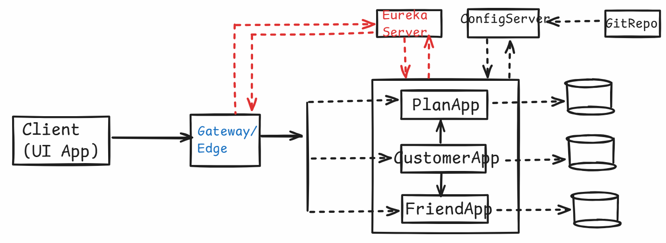

steps to create a gateway application:
--------------------------------------
- create a new spring boot application(Gateway) with dependecies
gateway, eureka discovery client, devtools.
- Add @EnableDiscoveryClient annotation on boot main class.
- Add the below properties in application.properties file.
eureka.client.service-url.defaultZone=http://localhost:8761/eureka/
server.port=2222
spring.cloud.gateway.discovery.locator.enabled=true
spring.cloud.gateway.discovery.locator.lower-case-service-id=true

- To test the Gateway,
- 1. start all the applications like,
- ConfigServerApp
- EurekaServer
- CustomerApp
- FriendApp
- PlanApp
- Gateway
- 2. open POSTMAN, and send a request.
- GET http://localhost:2222/planapp/plans
- GET http://localhost:2222/friendapp/friend/1001001001
- GET http://localhost:2222/customerapp/customer/profile/1001001001

Distributed tracing:
- In microservices architecture, a request can travel through dozens or hundreds of services.
- When an issue is arised, it can be challenging to pinpoint where the problem originated.
- The solution is, distributed tracing.
- Before Spring Boot 3.x, Spring Cloud Sleuth with Zipkin was used for distributed tracing.
- Spring Cloud Sleuth will not work with Spring Boot 3.x onward.
- The core functionality of Spring Cloud Sleuth has been migrated to Micrometer tracing. So, we can use Micrometer tracing with Zipkin from Spring Boot 3.x.
- Micrometer tracing generates traceId and spanId and injects them automatically into application logs.
- traceId is a unique id generated for the entire journey of a request.
- spanId is a single logical unit of work, and this id is generated for a call to another service.
- When Micrometer tracing is enabled, we need look into the application logs of each service, to pinpoint where the problem originated.
- But practically, it is very difficult when there are more number of services are executed per a request.
- So, we integrate this Micrometer tracing with Zipkin.
- Zipkin server is an open-source distributed tracing system, which provides a dashboard page for the developers to watch the request flow.
- Zipkin receives the span data from our services, will store it in an in-memory database, then analyzes the logs and provided a UI page to show the latency of each span, so that we can identify performance bottlenecks or error points.
- To integrate Micrometer tracing with Zipkin, we need to use a bridge called OpenTelemetry.

Microservices security:
- we can implement security at each microservice.
or
- we can implement security at api gateway.
- if we implement security at each microservice, the code should be duplicated at each microservice and also in future if any changes are required in security configurations, then the changes must be made at each service.
- The changes many take more time and we also need to restart the services. If multiple instances are started for a service, then all those instances must be restarted.
- That’s why we implment the security for the microservices at the gateway.
- We use Oauth2 framework/specification to implement the security for API Gateway application.
- Oauth2 protocol, has defined different grant types for different types of clients to get access token, in order to fetch the data from the resource server with access token.
- Mostly applications use either Authorization code grant type or client credentials grant type of Oauth2 framework, to get the access token.
- client credentials grant type is used for server-to-server communication, where the client(an application/service) accesses the API of the server(an application/service), but not on behalf of a user.
- For example, there is an e-commerce application called ShopEasy and it interacts with a payment processing application called PayFast to handle the payments.
- Here, ShopEasy server needs to interact with the PayFast API to process the payments or for generating invoices, etc.
- So, here the client credentials grant flow steps are,
- ShopEasy(client) register with the Authz Server of PayFast as a client.
- PayFast Authz server provides Client credentials to ShopEasy like client-id and client-secret.
- ShopEasy requests access token from Authz Server, provides its credentials in the request.
- Now, if client credentials are valid, then PayFast Authz server issues access token.
- ShopEasy application makes a call to the PayFast API, with this access token.
- PayFast application validates the access token and will process the request and sends the response to the ShopEasy application.

- We are going to setup the keycloak as Authorization Server and our API Gateway application as Resource server and Postman as a client application.
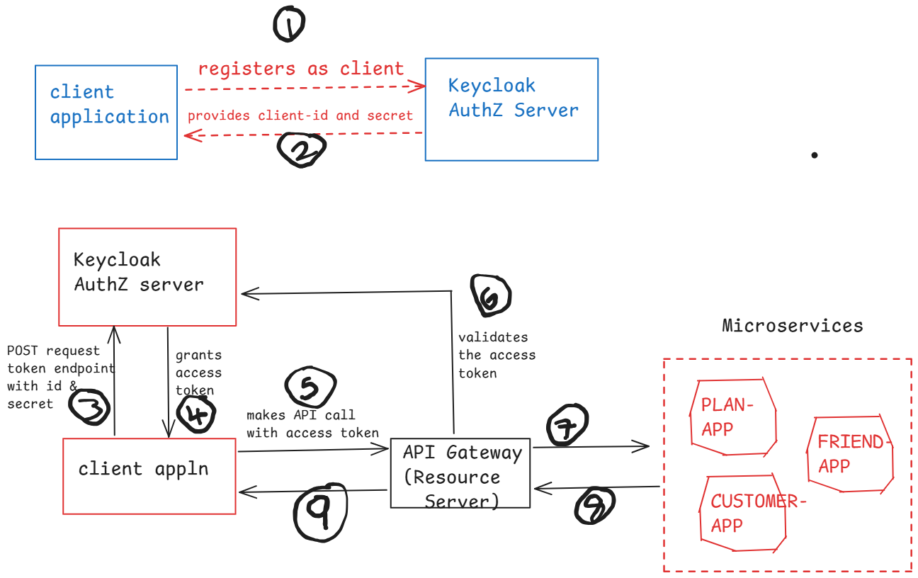
Client registration steps:
- install docker desktop on to your machine and then start
- start the keycloak authorization server as a docker container.
- visit https://www.keycloak.org/getting-started/getting-started-docker and copy the docker run command and execute it from the command prompt.
- docker run -d -p 127.0.0.1:7080:8080 -e KC_BOOTSTRAP_ADMIN_USERNAME=admin -e KC_BOOTSTRAP_ADMIN_PASSWORD=admin quay.io/keycloak/keycloak:26.3.1 start-dev

- after executing the docker run command, execute “docker ps” command, and check for the container started or not.
- open the browser and enter http://localhost:7080
username: admin
password: admin
- click on clients at left side ---> create client
- Client type: OpenID Connect
Client ID : demo-client-cc
Name: demo app
Description: demo application
Next button
- Client authentication : on
un-select : standard flow, and direct access grants
select : service accounts roles
- click on Next button then Save button.
10)click on credentials tab, verify that client secret is generated.
Note: with the above steps, client application is registered with keycloak authz server, and client-id and client-secret are generated.

changes to be made for Gateway application:
- add the below dependencies in pom.xml
<dependency>
<groupId>org.springframework.boot</groupId>
<artifactId>spring-boot-starter-security</artifactId>
</dependency>

<dependency>
<groupId>org.springframework.security</groupId>
<artifactId>spring-security-oauth2-resource-server</artifactId>
</dependency>

<dependency>
<groupId>org.springframework.security</groupId>
<artifactId>spring-security-oauth2-jose</artifactId>
</dependency>

- add the below properties in application.properties file.

spring.security.oauth2.resourceserver.jwt.issuer-uri=http://localhost:7080/realms/master
spring.security.auth2.resourceserver.jwt.jwk-set-uri=http://localhost:7080/realms/master/protocol/openid-connect/certs
spring.main.web-application-type: reactive
eureka.instance.hostname=localhost

- create a configuration class like below.
@Configuration
@EnableWebFluxSecurity
public class MySecurityConfiguration {

@Bean(name = "springSecurityFilterChain")
public SecurityWebFilterChain springSecurityFilterChain(ServerHttpSecurity httpSecurity) {
httpSecurity.authorizeExchange(exchanges -> exchanges.anyExchange().authenticated())
.oauth2ResourceServer(spec -> spec.jwt(Customizer.withDefaults()));

httpSecurity.csrf(csrf -> csrf.disable());
return httpSecurity.build();
}

@Bean
public JwtDecoder jwtDecoder(OAuth2ResourceServerProperties properties) {
return JwtDecoders.fromIssuerLocation(properties.getJwt().getIssuerUri());
}

}

- add the below property in application.yml file of all the microservices(CustomerApp, FrientApp and PlanApp).
eureka:
instance:
hostname: localhost

How to test microservices security:
- start all the applications
ConfigServerApp, EurekaServer, Gateway, CustomerApp, PlanApp, FriendApp, Zipkin
- Now send a POST request to the token endpoint of keycloak auth server
url: http://localhost:7080/realms/master/protocol/openid-connect/token
click on body tab, choose x-form-url-encoded and add the below key-value pairs.
key value
grant_type client_credentials
client_id demo-client-cc
client_secret paste the secret value
scope email profile
click on Send button.
- In response, you will receive access token.
- copy the access token, now send request to plan-app through Gateway, by adding access token to the Authorization header.
- http://localhost:7080/planapp/plans

Dockerizing Spring Boot application:

Virtualization:
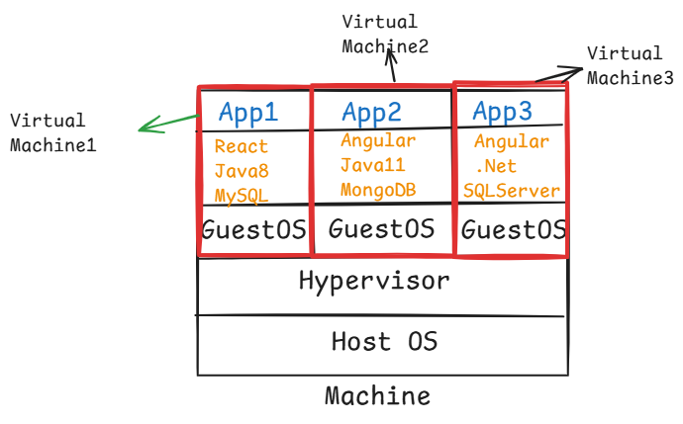
- Virtualization enables the creation and management of Virtual Machine. It virtualizes the hardware, and allows multiple operating systems to run the same physical machine.
- The physical machine has Host Operationg System and each VM has its own operating system called Guest Operating System.
- Each virtual machine is allocated with CPU, Memory(RAM) and Storage.
- When you boot-up the physical machine, it will take more time because into each VM, its Guest OS must be fully loaded. So it decreases the performance of the physical machine.

containerization:

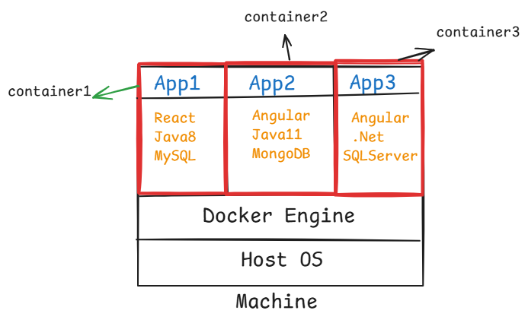
- Docker is a containerization platform which enables the creation of lightweight environments called containers.
- containers uses shared Operating System kernal and creates isolated environments for running applications.
- containers are lightweight, because they don’t include the entire OS, they only contain the application code and application dependencies.
- containers are faster because they don’t boot an OS.

Dockerizing Spring Boot application:
-----------------------------------

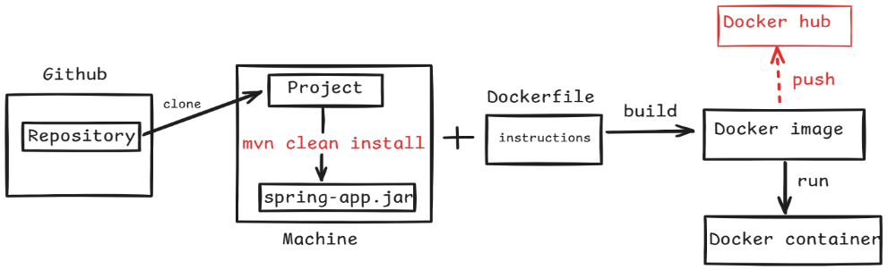

step-1: create a new spring boot rest application.
- create a rest controller class(HelloController), with
HTTP GET endpoint /hello, to return a welcome message.
step-2: package the application as a jar file.
- Right click on the project RunAs maven build… Goal: clean install Run
- Refresh the project
step-3: create Dockerfile in the project directory.
# Use a base image as jdk 17
FROM openjdk:17-jdk-slim

# Copy the Spring Boot jar file into the container
COPY target/SB-Hello-App-0.0.1-SNAPSHOT.jar /usr/app/

# Set the working directory inside the container
WORKDIR /usr/app/

# Expose the port the app runs on
EXPOSE 8080

# Run the Spring Boot application
ENTRYPOINT [ "java","-jar","SB-Hello-App-0.0.1-SNAPSHOT.jar" ]

step-4: start the Docker engine.
- double click on Docker Desktop icon

step-5: Build the docker image
- open command prompt and move to the project location.
- execute the below command
docker build -t my-spring-boot-app .
Note: Here .(dot) refers the current directory where the Dockerfile is located.

step-6: Run the Docker container
- After building the image, you can run the spring boot application inside a Docker container.
- execute the below command
docker run -d -p 8080:8080 my-spring-boot-app

step-7: Test the application.
http://localhost:8080/hello

Dockerizing Spring Boot + MySQL

step-1:
create a new Spring Boot Rest application
- create a rest controller class, entity class, service class, repository interface.
step-2:
build the spring boot application as jar
- Right click on the project RunAs maven build… Goal: clean install -DskipTests Run
- Refresh the project
step-3: create Dockerfile in the project directory.
# Use a base image as jdk 17
FROM openjdk:17-jdk-slim

# Copy the Spring Boot jar file into the container
COPY target/SB-Book-Rest-App-0.0.1-SNAPSHOT.jar /usr/app/

# Set the working directory inside the container
WORKDIR /usr/app/

# Expose the port the app runs on
EXPOSE 8080

# Run the Spring Boot application
ENTRYPOINT [ "java","-jar","SB-Book-Rest-App-0.0.1-SNAPSHOT.jar" ]

step-4: start the Docker engine.
- double click on Docker Desktop icon

step-5: Build the docker image
- open command prompt and move to the project location.
- execute the below command
docker build -t my-spring-book-rest-app .
Note: Here .(dot) refers the current directory where the Dockerfile is located.
step-6:
create a docker network with the below command.
- docker network create sb-mysql-network
- To verify the network is created or not,
- docker network ls

step-7: create docker-compose.yml in the project directory.
version: "3.8"

services:
application:
image: my-spring-book-rest-app
container_name: spring-container
ports:
- "8080:8080"
networks:
- sb-mysql-network
depends_on:
- mysqldb
deploy:
restart_policy:
condition: on-failure
max_attempts: 10
mysqldb:
image: mysql:8.0
container_name: mysqldb-container
ports:
- "3306:3306"
networks:
- sb-mysql-network
environment:
- MYSQL_ROOT_PASSWORD=root
- MYSQL_DATABASE=test
networks:
docker-mysql:
name: sb-mysql-network
external: true

step-8: execute the below command from the command prompt at project directory.
- docker compose up -d
step-9: open postman to test the api endpoints.
POST http://localhost:8080/add
add the below sample JSON in request body.
{
“bookId”: 10101,
“bookName”: “Java”,
“author”: “Gosling”
}

GET http://localhost:8080/fetch

Note: If you want to stop the containers started by docker compose, execute the below command.
- docker compose down

https://github.com/ShekherJava/SB-Book-Rest-App.git

Spring Boot + MongoDB
- Download mongodb from https://www.mongodb.com/try/download/community
- mongodb-windows-x86_64-7.0.16-signed.msi file will be downloaded.
- install mongodb by double click on the downloaded file.
- MongoDB is a NoSQL database that stores data in a flexible, JSON-like format called documents. It is widely used for its ease of use and scalability.
- Database: A container for collections.
- Collection: Similar to a table in relational databases, it is a group of documents.
- Document: A single record in a collection, stored in a JSON-like format (BSON internally).

https://github.com/ShekherJava/SB-MongoDB-CRUD.git

Testing CRUD operations using POSTMAN:

- create employee
POST http://localhost:8082/api/employees

{
“id”: 101,
“name”: “John”,
“salary”: 4000
}
Note: create multiple employees.
- Get all employees
GET http://localhost:8082/api/employees

- Get employee by ID
GET http://localhost:8082/api/employees/{id}

- Update employee
PUT http://localhost:8082/api/employees/{id}
{
“name”: “Waden”,
“salary”: 8000
}

- Delete employee
DELETE http://localhost:8082/api/employees/{id}

Logging in Spring Boot:
- We can write System.out.println() statements in our code, to check whether the control has reached upto a specific point in the code or not.
- But with S.o.p statements, we have have some issues like two threads can’t execute S.o.p statement at a time and the messages are displayed on the console. So, we can’t use these messages for debugging.
- So, we write log statements instead of S.o.p statements in an application.
- Log statements are the records of events that happen in our application.
- log statements contains timestamp information like when the event was happened, what happened at that time, which thread was processing at that time, etc.
- log statements helps us to monitor and analyze our application, and also for troubleshooting and debugging tasks.
- Spring Boot by default uses logging framework as Logback.
- We can also use either Log4j2 or Java Util Logging as a logging framework in spring boot.
- In a spring boot application, we write the log statements using SLFJ API. This api delegates the logging calls to the underlying logging implementation.
- SLF4J (Simple Logging Façade for Java) is not a logging framework. Instead, it is an abstraction for logging frameworks like Logback, Log4j2, etc.
- SLF4J allows the developers to write the code independent of the logging framework.
- Each log statement has a log level and choosing the appropriate log level is crucial for maintaining clarity.
- The log levels are,
TRACE
DEBUG
INFO
WARN
ERROR
- TRACE is used for tracing the internal flow of a program. It is used for very low-level operations.
- For example, like tracing the method entry/exit point, or like detailed application flow like loops or recursive methods.
- DEBUG is used for logging the information that helps developers to debug the application.
- For example, like showing the current state of an object or logging the variable values like the current user who has logged in or the orderid of the order processed etc.

logger.debug(“Current user : {}”, currentUser);
logger.debug(“Order processed with id : {}”, orderId);
- INFO is used to log the general information about the application state.
- For example, like logging the application startup or shutdown events or for recording the successful operations like “Order places” or “File uploaded”, etc.
- WARN indicates potentially harmful situations in the application, but it does not cause shutdown, but might require some attention.
- For example, like some feature is deprecated or some configuration is missing, etc.
- ERROR is used to log error events that disrupt the operation. So, immediate action/attention is required.
- For example, logging the exceptions stack trace or logging the database connection failures etc.

- The default logging behavior in spring boot is,

1.logs are displayed on console
2.The default logging level is INFO
3.Uses logback as the default logging implementation.

- To write a log statement in a spring boot application like in a controlller class or in a service class, etc., then you need to create a Logger object like below.

private static final Logger logger = LoggerFactory.getLogger(classname.class);
For example:
@RestController
public class WelcomeController {
private static final Logger logger = LoggerFactory.getLogger(WelcomeController.class);
@GetMapping(value = “/welcome/{username}”)
public String sayWelcome(@PathVariable String username)
{
logger.info(“The current username : {}”, username);
return “welcome : “ + username;
}
}

- The configuration settings in application.properties file.
#default logging level for the entire application
logging.level.root=INFO

#logging level for specific packages
logging.level.com.example=DEBUG

logging.level.org.springframework.web=ERROR

- logginging.level.root applies to all the loggers in the application, unless they have configured with a specific logging level.
- To write/store the logs in a file,
logging.file.name=application.log
logging.file.path=/logs

