Cloning
. Cloning is a process of creating a duplicate object from an exisitng object.
. When creating complex objects, cloning is used.
. Instead of creating an object from scratch, we can clone exisiting objec to create a duplicate object.
. Once an object is cloned, the original and duplicate objects acts independently. The changes made to the original object, doesn’t effect on duplicate object and vice-versa.
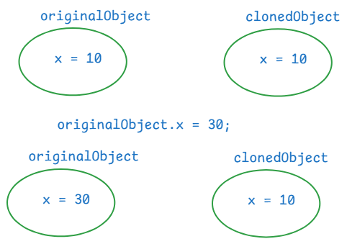
. For example, in a gaming application, we need multiple enemies with the same characterstics. So, we create one enemy object, and we clone this object to create multiple enemies.

How to clone an object?
. first implement a class, whose objects requires cloning from java.lang.Cloneable marker interface.
. we have to override clone() method of Object class, in that class.
//example
package com.ashokit.cloning;

class ClassA implements Cloneable {
private int x;
private int y;

ClassA(int x, int y) {
// System.out.println("ClassA(int,int): constructor");
this.x = x;
this.y = y;
}

//Here, you are overriding clone() method of Object class
@Override
protected Object clone() throws CloneNotSupportedException {
return super.clone();
}

//Here, you are overriding toString() method of Object class
@Override
public String toString() {
return "ClassA [x=" + x + ", y=" + y + "]";
}

public int getX() {
return x;
}

public void setX(int x) {
this.x = x;
}

public int getY() {
return y;
}

public void setY(int y) {
this.y = y;
}

}

public class Main {

public static void main(String[] args) throws CloneNotSupportedException {

ClassA ca = new ClassA(10, 20);

ClassA clonedCa = (ClassA) ca.clone();

System.out.println("original object : " + ca);
System.out.println("cloned object : "+ clonedCa);

//make changes to original object

ca.setX(30);
ca.setY(40);

System.out.println("==============================");
System.out.println("After making changes in original object");

System.out.println("original object : " + ca);
System.out.println("cloned object : "+ clonedCa);
}

}
output:
original object : ClassA [x=10, y=20]
cloned object : ClassA [x=10, y=20]
==============================
After making changes in original object
original object : ClassA [x=30, y=40]
cloned object : ClassA [x=10, y=20]

Types of cloning:
- shallow cloning
- deep cloning
. In shallow cloing, when a dependent object is cloned, its dependency object will not be cloned. It means, both original and cloned dependent objects will share the same dependency object.
. In deep cloning, when a dependent object is cloned, its dependency object is also cloned. So, both original and cloned dependent objects have separate dependency objects.
. In shallow cloning, dependent class implements Cloneable interface, but dependency class doesn’t.
. In deep cloning, both the classes implements Cloneable interface.

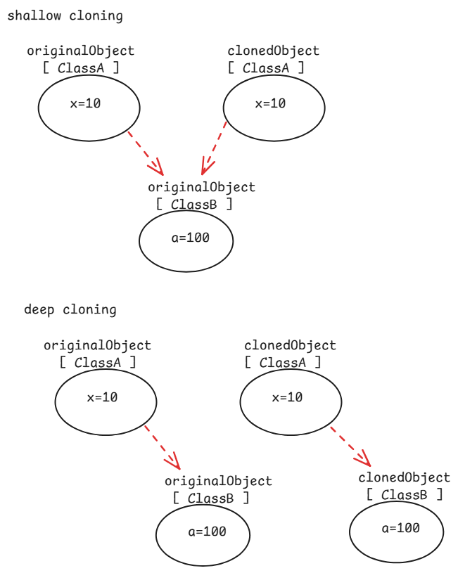

// shallow cloning example
package com.ashokit.cloning;

//dependent class
class ClassA implements Cloneable {
private int x;
private int y;
private ClassB classB;

ClassA(int x, int y) {
// System.out.println("ClassA(int,int): constructor");
this.x = x;
this.y = y;
classB = new ClassB(100, 200);
}

@Override
protected Object clone() throws CloneNotSupportedException {
return super.clone();
}

@Override
public String toString() {
return "ClassA [x=" + x + ", y=" + y + ", classB=" + classB + "]";
}

public int getX() {
return x;
}

public void setX(int x) {
this.x = x;
}

public int getY() {
return y;
}

public void setY(int y) {
this.y = y;
}

public ClassB getClassB() {
return classB;
}

public void setClassB(ClassB classB) {
this.classB = classB;
}

}

//dependency class
class ClassB {
private int a;
private int b;
ClassB(int a, int b) {
this.a = a;
this.b = b;
}
@Override
public String toString() {
return "ClassB [a=" + a + ", b=" + b + "]";
}
public int getA() {
return a;
}
public void setA(int a) {
this.a = a;
}
public int getB() {
return b;
}
public void setB(int b) {
this.b = b;
}

}

public class Main {
public static void main(String[] args) throws CloneNotSupportedException {

ClassA ca = new ClassA(10,20);
ClassA clonedCa = (ClassA) ca.clone();

System.out.println("original object : " + ca);
System.out.println("cloned object : " + clonedCa);

System.out.println("======================================");
//making a change in the dependency object through original dependent object
ca.getClassB().setA(99);
ca.getClassB().setB(199);

System.out.println("After changing dependency object, through original dependent object");
System.out.println("original object : "+ ca);
System.out.println("cloned object : " + clonedCa);

}

}
output:
original object : ClassA [x=10, y=20, classB=ClassB [a=100, b=200]]
cloned object : ClassA [x=10, y=20, classB=ClassB [a=100, b=200]]
======================================
After changing dependency object, through original dependent object
original object : ClassA [x=10, y=20, classB=ClassB [a=99, b=199]]
cloned object : ClassA [x=10, y=20, classB=ClassB [a=99, b=199]]
//deep cloning example.
package com.ashokit.cloning;

//dependent class
class ClassA implements Cloneable {
private int x;
private int y;
private ClassB classB;

ClassA(int x, int y) {
// System.out.println("ClassA(int,int): constructor");
this.x = x;
this.y = y;
classB = new ClassB(100, 200);
}

@Override
protected Object clone() throws CloneNotSupportedException {
ClassB clonedB = (ClassB) classB.clone();
ClassA clonedA = (ClassA)super.clone();
clonedA.setClassB(clonedB);
return clonedA;
}

@Override
public String toString() {
return "ClassA [x=" + x + ", y=" + y + ", classB=" + classB + "]";
}

public int getX() {
return x;
}

public void setX(int x) {
this.x = x;
}

public int getY() {
return y;
}

public void setY(int y) {
this.y = y;
}

public ClassB getClassB() {
return classB;
}

public void setClassB(ClassB classB) {
this.classB = classB;
}

}

//dependency class
class ClassB implements Cloneable {
private int a;
private int b;

ClassB(int a, int b) {
this.a = a;
this.b = b;
}

@Override
protected Object clone() throws CloneNotSupportedException {
return super.clone();
}

@Override
public String toString() {
return "ClassB [a=" + a + ", b=" + b + "]";
}
public int getA() {
return a;
}
public void setA(int a) {
this.a = a;
}
public int getB() {
return b;
}
public void setB(int b) {
this.b = b;
}

}

public class Main {
public static void main(String[] args) throws CloneNotSupportedException {

ClassA ca = new ClassA(10,20);
ClassA clonedCa = (ClassA) ca.clone();

System.out.println("original object : " + ca);
System.out.println("cloned object : " + clonedCa);

System.out.println("======================================");
//making a change in the dependency object through original dependent object
ca.getClassB().setA(99);
ca.getClassB().setB(199);

System.out.println("After making changes to the dependency object, through original dependent object");

System.out.println("original object : "+ ca);
System.out.println("cloned object : " + clonedCa);

}

}
output:
original object : ClassA [x=10, y=20, classB=ClassB [a=100, b=200]]
cloned object : ClassA [x=10, y=20, classB=ClassB [a=100, b=200]]
======================================
After making changes to the dependency object, through original dependent object
original object : ClassA [x=10, y=20, classB=ClassB [a=99, b=199]]
cloned object : ClassA [x=10, y=20, classB=ClassB [a=100, b=200]]

serialization & deserialization
- serialization is a process of converting a Java object into a stream of bytes, which can be easily saved in a file, transmitted over a network or stored in a database.
- deserialization is a reverse process of serialization. The stream of bytes are collected from a file, or network, or a database and converted back to a Java object.
- we serialize an object, when we want to save the state of an object into a file, or we want to send an object to another machine.
- To serialize a Java object, the class should implement a marker interface, java.io.Serializable.
- We use ObjectOutputStream class for serialization and ObjectInputStream class for deserialization.
- The writeObject() of ObjectOutputStream class converts a Java object into a stream of bytes.
- The readObject() of ObjectInputStream class converts a stream of bytes into a Java object.

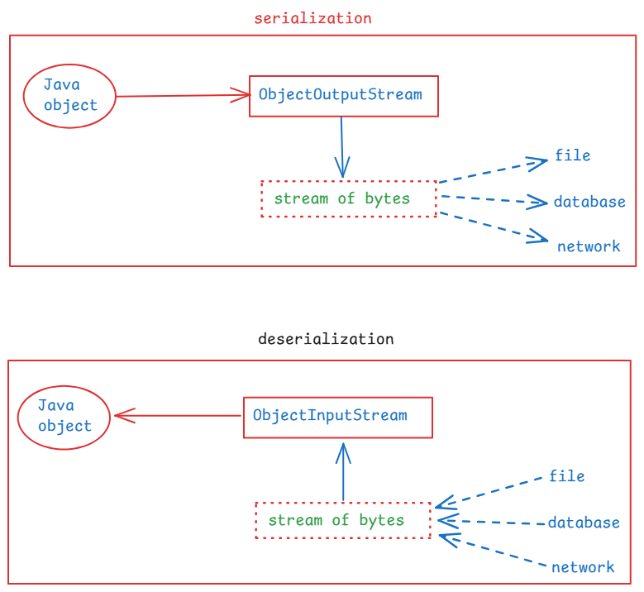
// A demo on serialization

package com.ashokit.demo;
import java.io.FileInputStream;
import java.io.FileOutputStream;
import java.io.IOException;
import java.io.ObjectInputStream;
import java.io.ObjectOutputStream;
import java.io.Serializable;

class Employee implements Serializable {

int empno;
String ename;

Employee(int empno, String ename) {
this.empno = empno;
this.ename = ename;
}

@Override
public String toString() {
return "Employee [empno=" + empno + ", ename=" + ename + "]";
}
}

public class Main {

public static void main(String[] args) {

Employee emp = new Employee(7878, "Scott");

//serialization
try ( FileOutputStream fileOut = new FileOutputStream("D:\\employee.ser");
ObjectOutputStream out = new ObjectOutputStream(fileOut)) {
out.writeObject(emp);
}
catch(IOException ie) {
ie.printStackTrace();
}

//deserialization
Employee deserializedEmp = null;

try ( FileInputStream fileIn = new FileInputStream("D:\\employee.ser");
ObjectInputStream in = new ObjectInputStream(fileIn)) {
deserializedEmp = (Employee) in.readObject();
}
catch(IOException | ClassNotFoundException ex) {
ex.printStackTrace();
}

System.out.println("Deserialized Employee : "+ deserializedEmp);

}

}

what is serialVersionUID?
. It is a unique identifier for each class that implements Serializable interface.
. It must be declared as a private static final long variable.
private static final long serialVersionUID = 1L;
. when an object is serialized, the serialVersionUID is also included in the stream of bytes.
. At the time of deserialization, JVM checks the id of the class and the id in the stream of bytes. If they match then only deserialization will proceed.
. Otherwise, JVM throws InvalidClassException.

what is transient keyword?
. If you want to stop any attribute of a class from serialization then you have to declare that variable as transient.
. when an object is serialized, the transient variable value will be stored as null, into the file.
. transient keyword can be used with only variables. Not with classes, interfaces or methods.
For example,
public class User implements Serializable {
private String username;
private transient String password;
//methods
}

( Please also refer Externalizable interface )

enum keyword:
-------------
. enum stands for enumeration.
. enum keyword is used to create a special data type.
. When you want to create a variable and that should be allowed to
store only one of the fixed set of constants as a value, then you
should create a special data type with enum keyword.
ex:
public enum Day {
MONDAY, TUESDAY, WEBNESDAY, THURSDAY, FRIDAY, SATURDAY, SUNDAY
}
. The constants in enum, are implicity static and final. So, we write the constants in upper case, but it is not a strict rule.

. You can create a variable of enum type as,
Day day;
. The variable can store one of the constants.
day = Day.MONDAY;
. Enums can also have fields, constructors and methods.
ex:
Gender.java
public enum Gender {
MALE("Male Person"), FEMALE("Female Person"), OTHERS("Other persons");

private String str; //field

Gender(String str) { //constructor
this.str = str;
}

public String getStr() { //method
return str;
}

public String sayHello() { //method
return "hello";
}

}
TestClass.java
public class TestClass {

public static void main(String[] args) {

Gender gender = Gender.MALE;
System.out.println(gender.sayHello()+ " : "+gender.getStr());

Gender gender2 = Gender.FEMALE;
System.out.println(gender2.sayHello()+ " : "+gender2.getStr());

//values(): returns an array of all enum constants
for(Gender g : Gender.values()) {
System.out.println(g);
}
}

}

JVM internal components:
- class loader
- runtime data areas
- execution engine
- Java Native Interface(JNI)
- Native Method libraries

. Class Loader is responsible for loading class files into JVM.
. Before JDK11, we have 3 types of class loaders.
- Bootstrap class loader: loads the classes from Java API
- Extension class loader: loads the classes from extensions
directory( jre/lib/ext).
- Application class loader: loads the classes from the
application classpath
. From JDK11, we have 2 types of class loaders.
- Bootstrap class loader
- Application class loader
. Runtime data areas are,
1.method area: stores the class level information.
static variables, class structures and methods are
stored in this method area.
2.heap area: stores objects and arrays.
3.stack area: stores local variables, partial results of threads.
4.PC registers: Each thread has a Program Counter(PC), it holds the
address of the current instruction being executed by
the thread.
5.Native method stack: Manages native(non-Java) method calls.
. Execution Engine: It is responsible for reading byte code and executing it.
. Execution engine contains,
- interpreter
- Just-In-Time compiler(JIT)
- Garbage Collector(GC)
. JNI allows the JVM to interact with native applications written in other languages like C/C++.
. Native method libraries are OS specific libraries and these will perform some tasks related system resources. JVM will access these libraries via JNI.

